ADMIN DASHBOARD

LOGIN PAGE

Firstly you have to login with your Username and Password which is provided from our side,
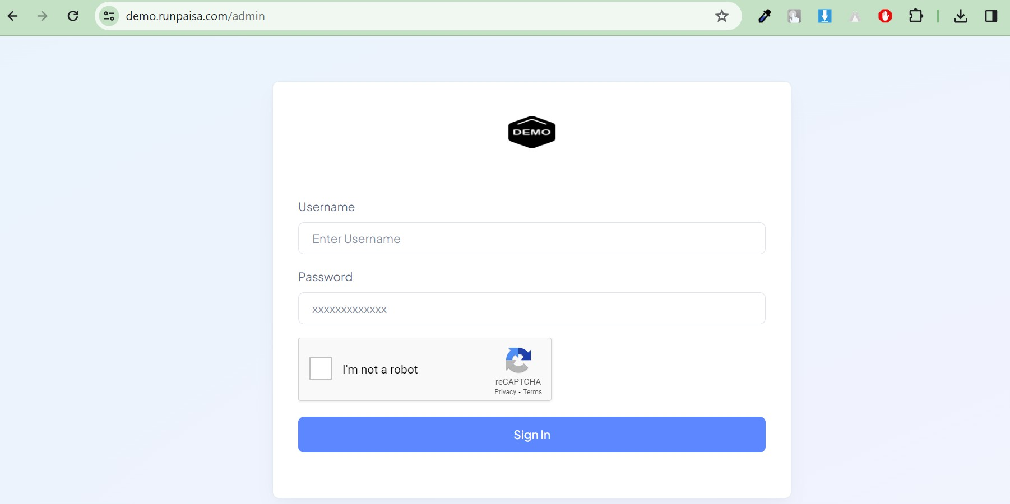

Then you will come to OTP page, enter the OTP which will be sent to your provided mobile number,

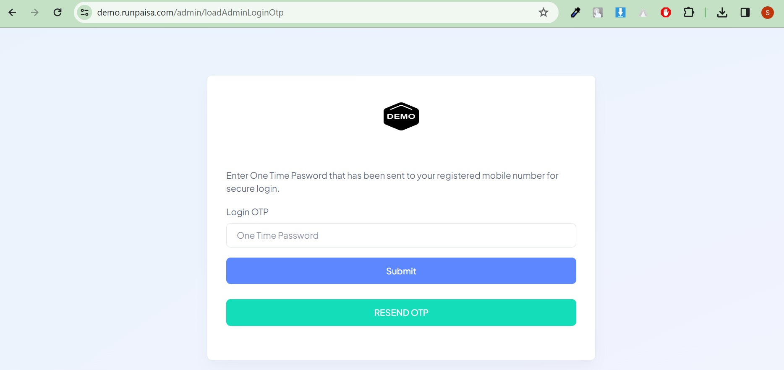

After that you will come to Admin dashboard.

DASHBOARD
In the Dashboard you can see following details:

- Today’s Revnue:
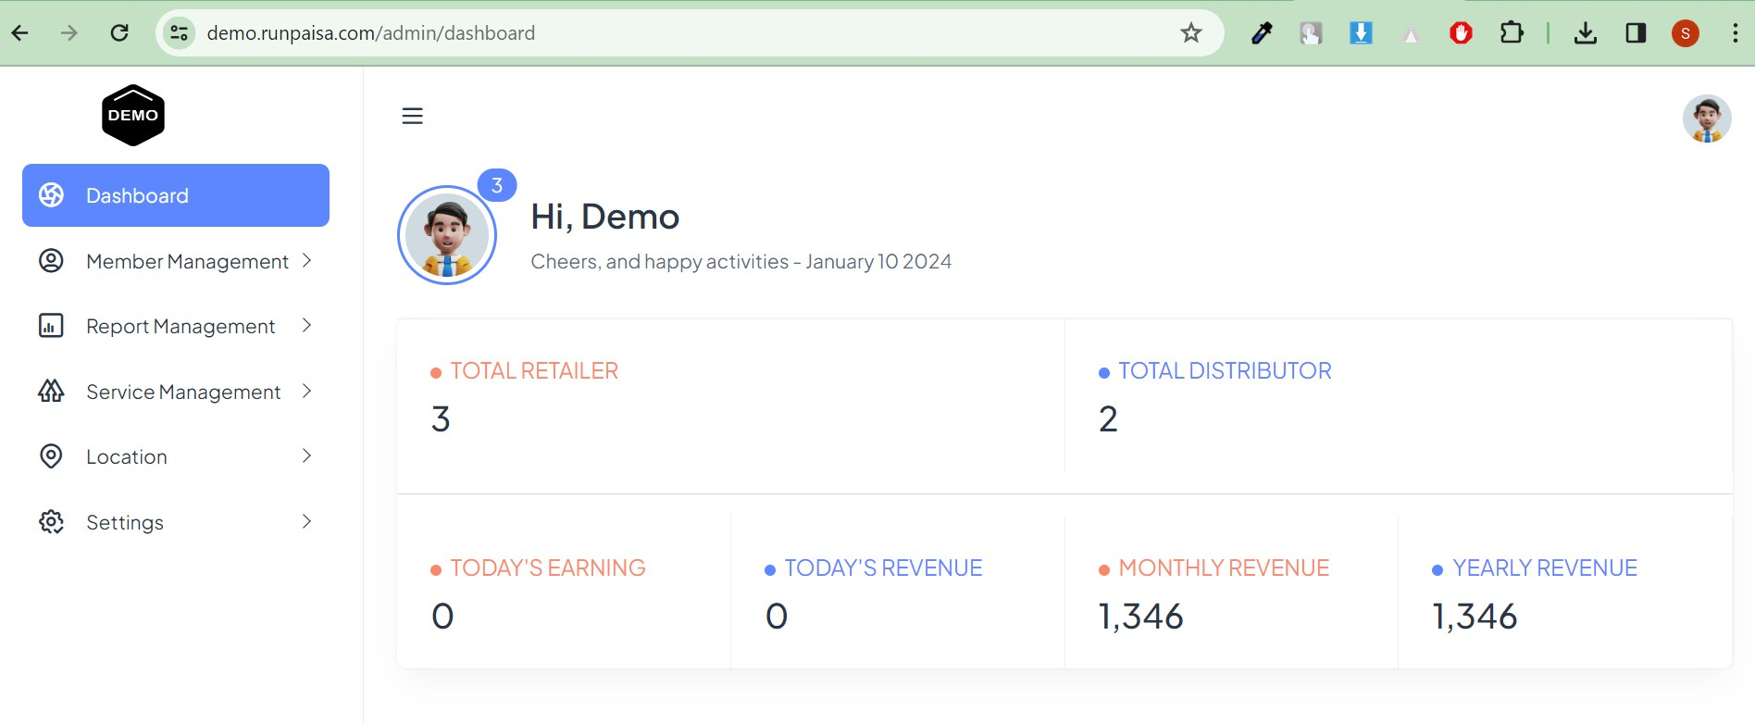

Your total Distributors and total Retailers number can be seen in this dashboard page.

Your one day Total Earnings and Total Revenue can be seen here(your total credit, settled, not settled, initiated all are included in these in one day).

One can navigate from sidebar menu, which are mentioned in below descriptions.

MEMBER MANAGEMENT
In the member management you can add and manage your members with different given functionalities, and In member management there is a dropdown menu which are mentioned below:
  - Add Member
  - View Distributor List
  - View Retailer List
  - Member balance

Add Member
- First page is for personal information, here you fill the basic details as per the required fields.
- At customer field you have to select the distributor or retailer that you want to create, then their basic details, then submit.
- Your created member can be seen in the distributor or retailer list accordingly.
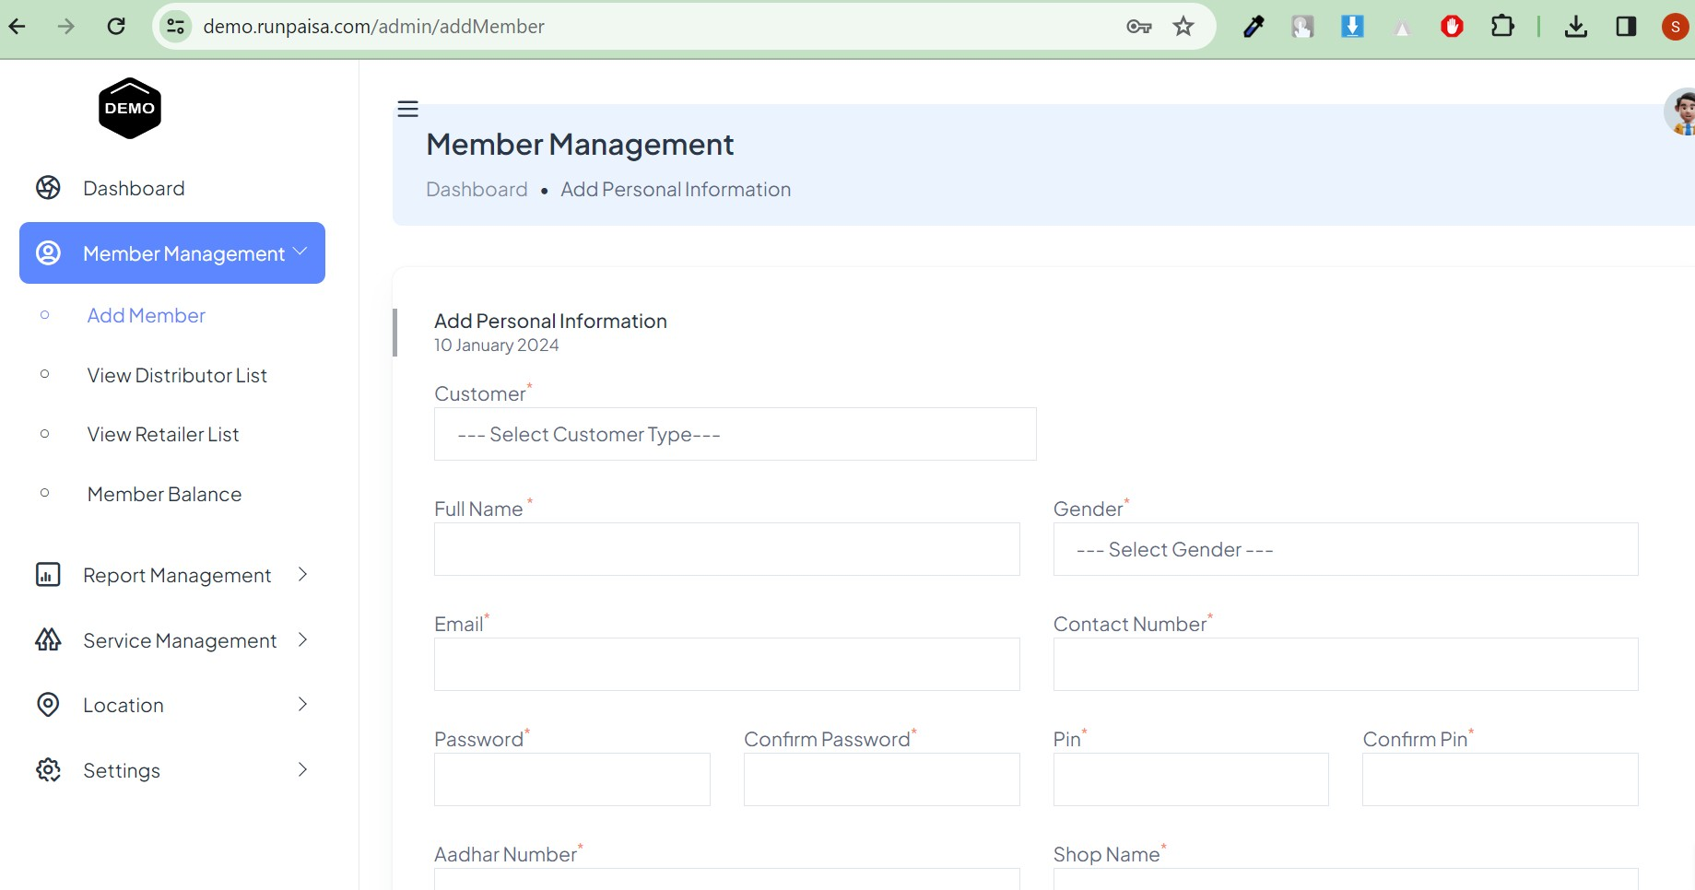

In this form one field is for pin which is used for send money from admin to distributor or retailer and in retailer panel while sending money to their customers.

View Distributor List
In Distributor list, all your distributors shown here and you can make changes with the help of action buttons which are mentioned below stepwise:-

Click on Hamburger Button, you will see different button under action column in distributor list.
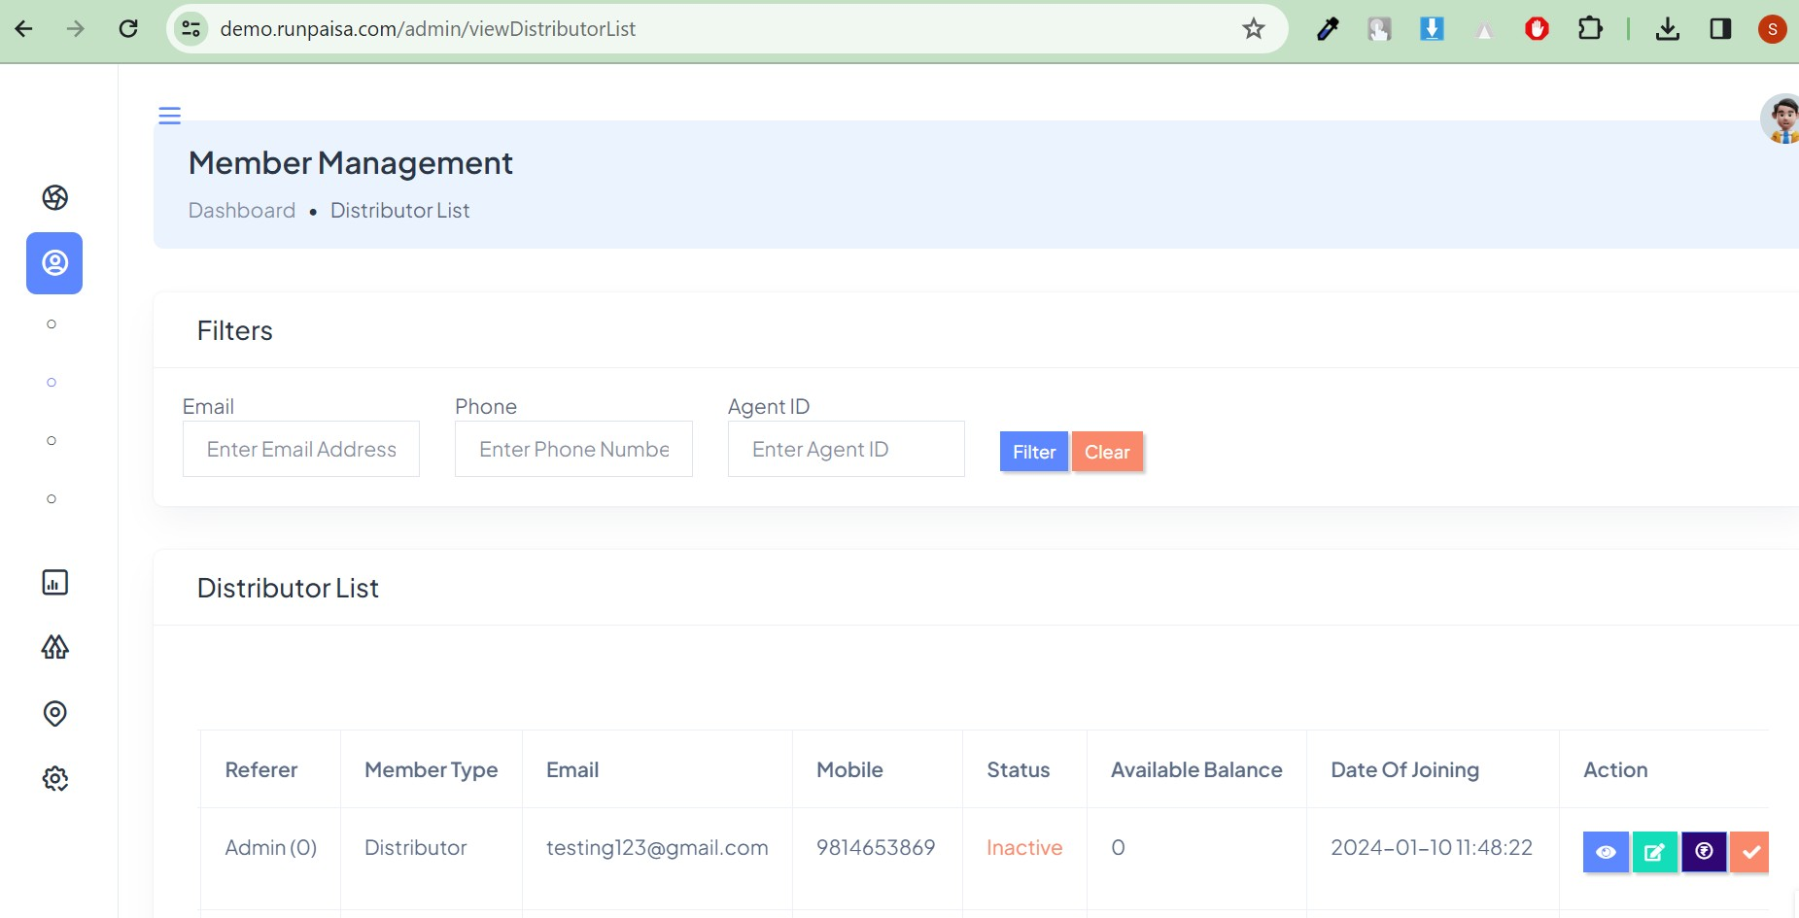

Action buttons
In distributor list, one column is actions where we have Four buttons these are described briefly and with example are as following:-

  - 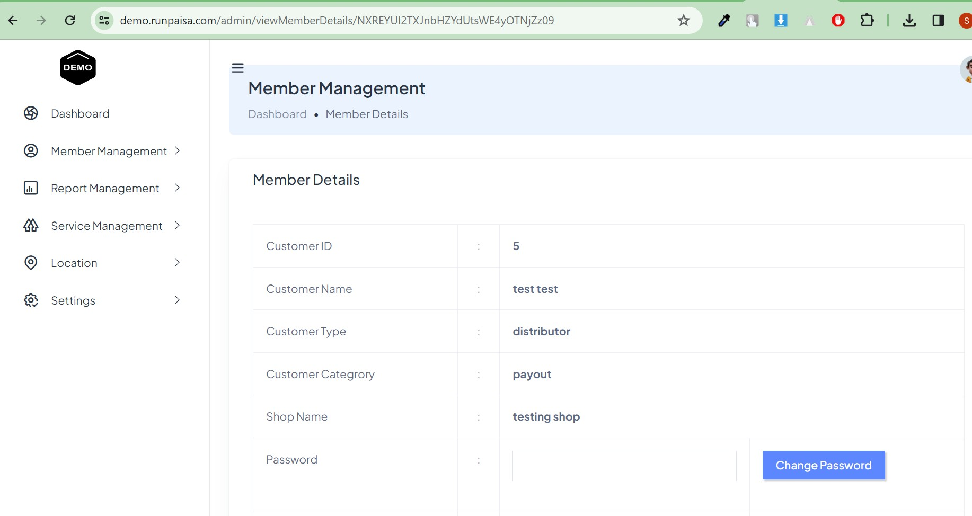Eye button- You can see the details of the selected member. Click on eye button for view details:-
In this view details page you may change the customer from distributor to retailer and retailer to distributor.

  - Edit button- You can edit the selected member that procedures are described below with more details. Click on Edit button:-
    - Edit/update for personal information

    - 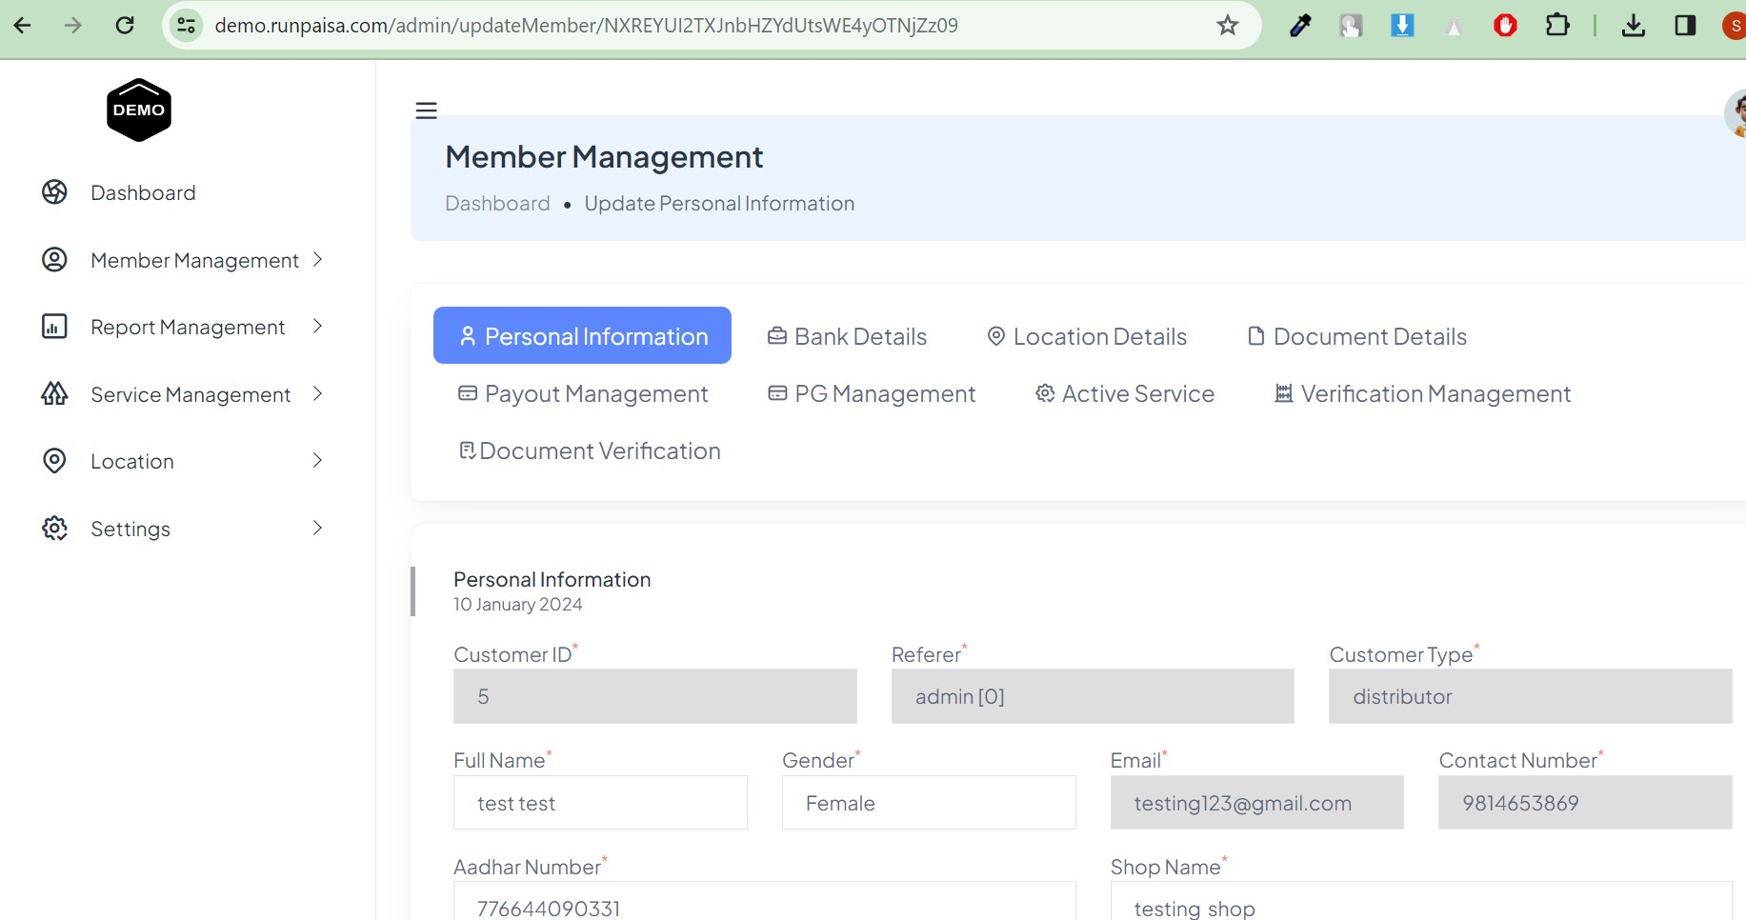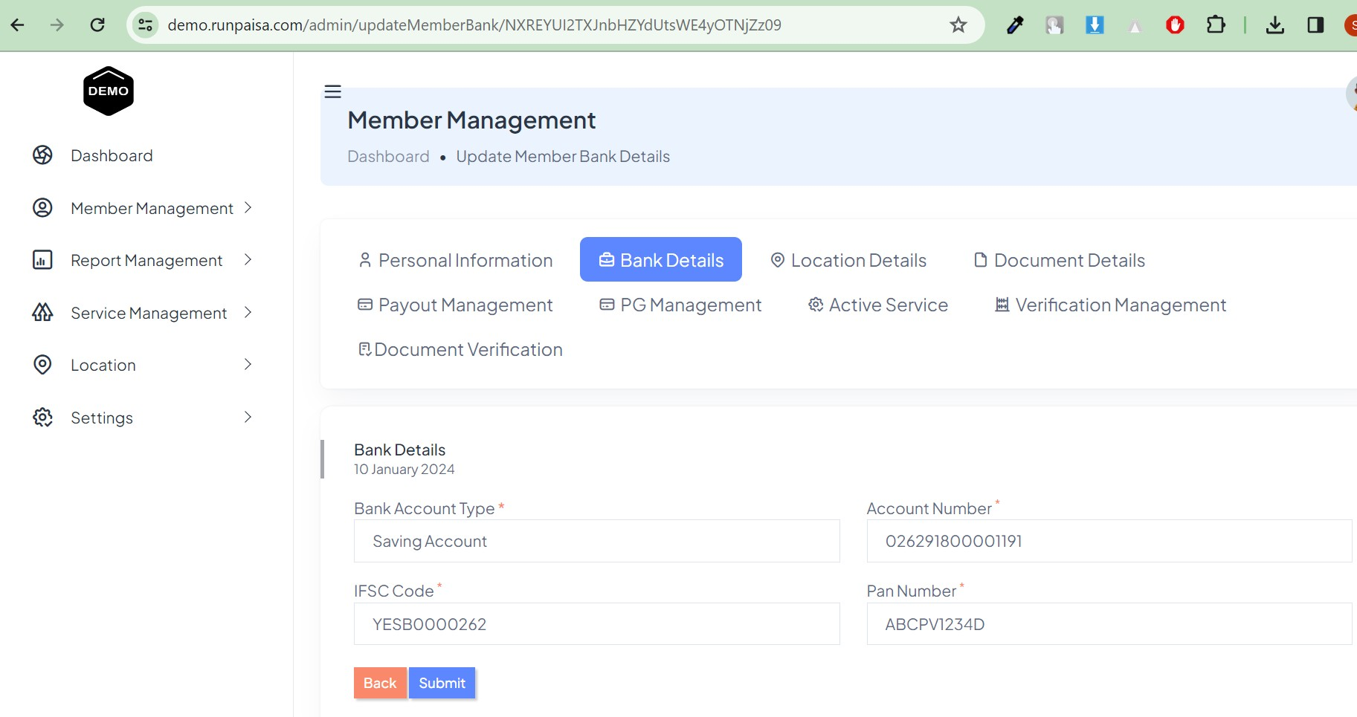Edit/Update for bank details:-

    - Edit/update for Location details

    - 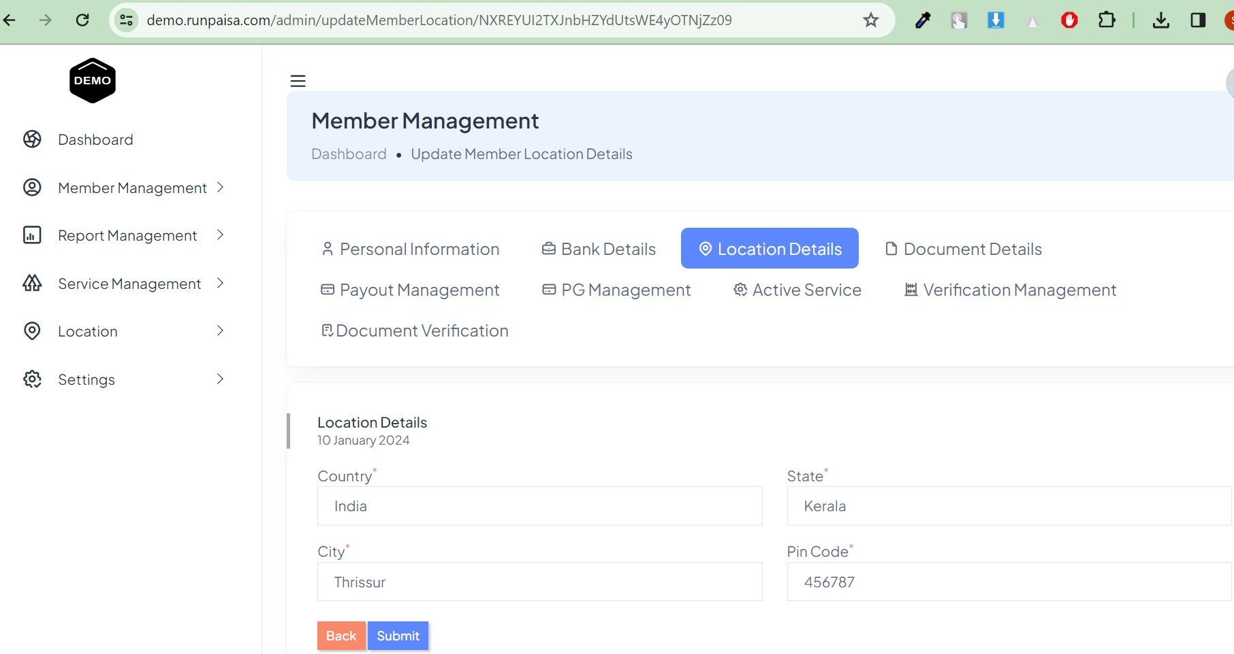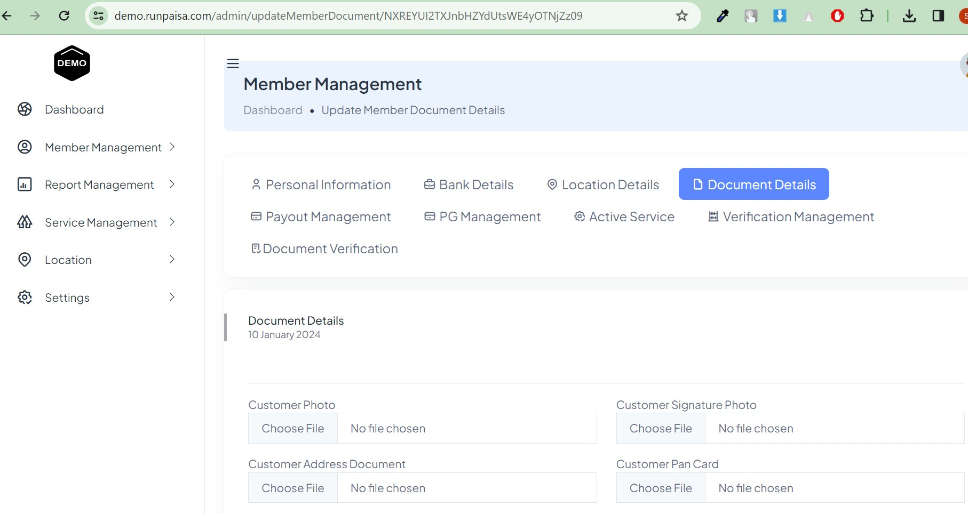Edit/update for Document details

    - Edit/update Payout Management
Here payout commercials will be set by you for your members & you have to active the commission field.

    - 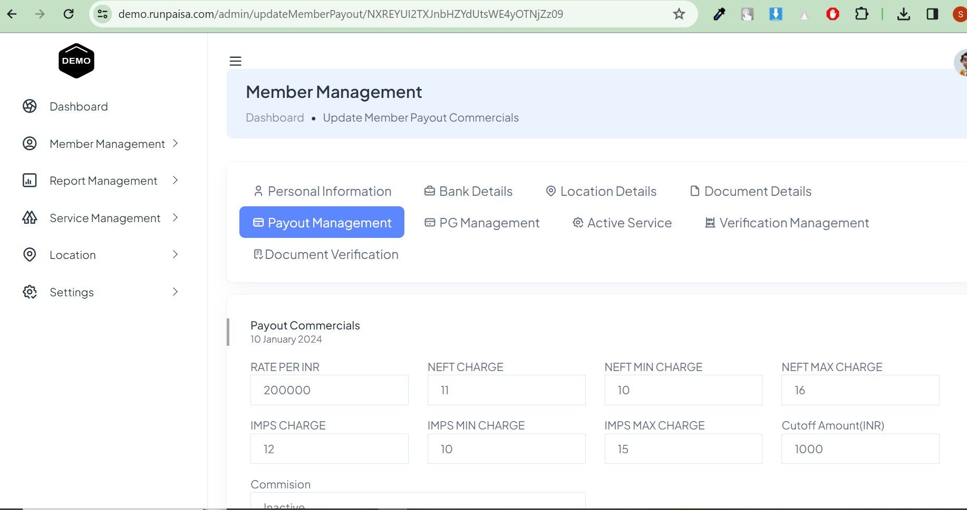Edit/Update for PG management
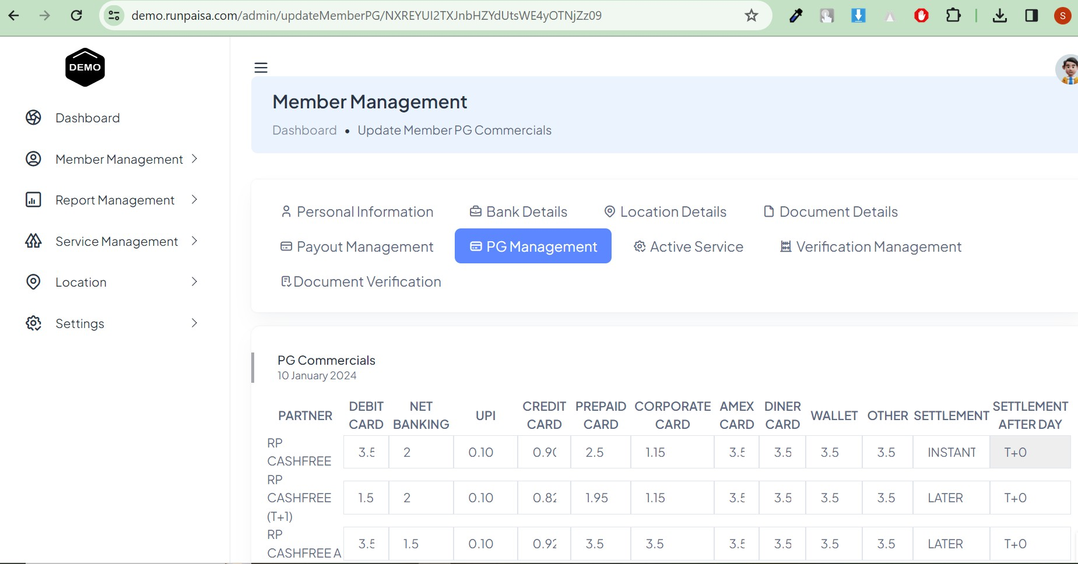Here you can set the PG(paymentgateway) Commercials/rate for your member but it should be more than the rate which are provided to you, otherwise commissions will be in negative.

    - Edit/update for Active Services Click the button under action

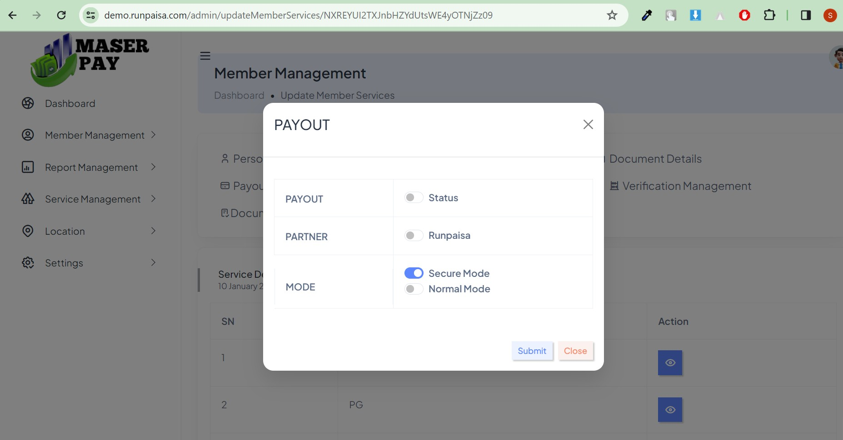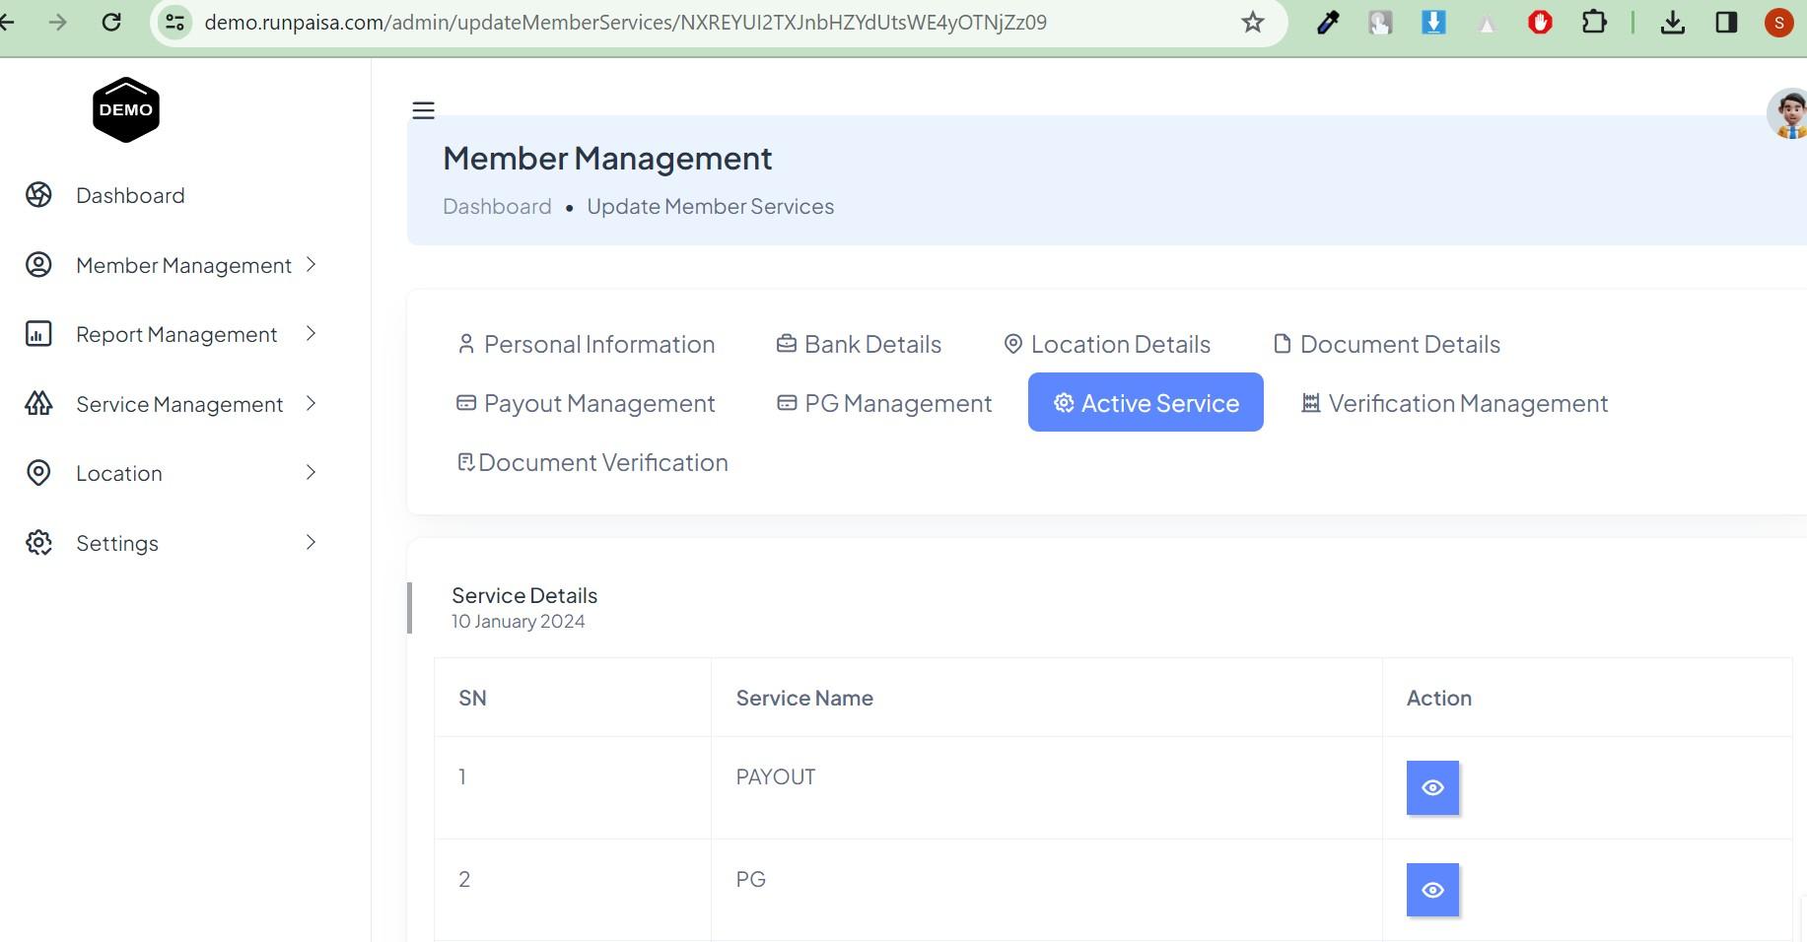Pop up shown to active/inactive the selected service.

- Verification Management
These are different charges like UPI, BAV, BIN, GST, ANV, PAN for verification.

  - 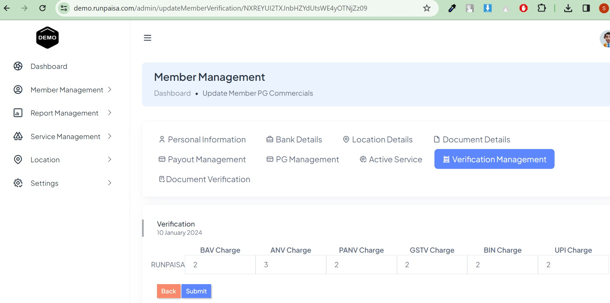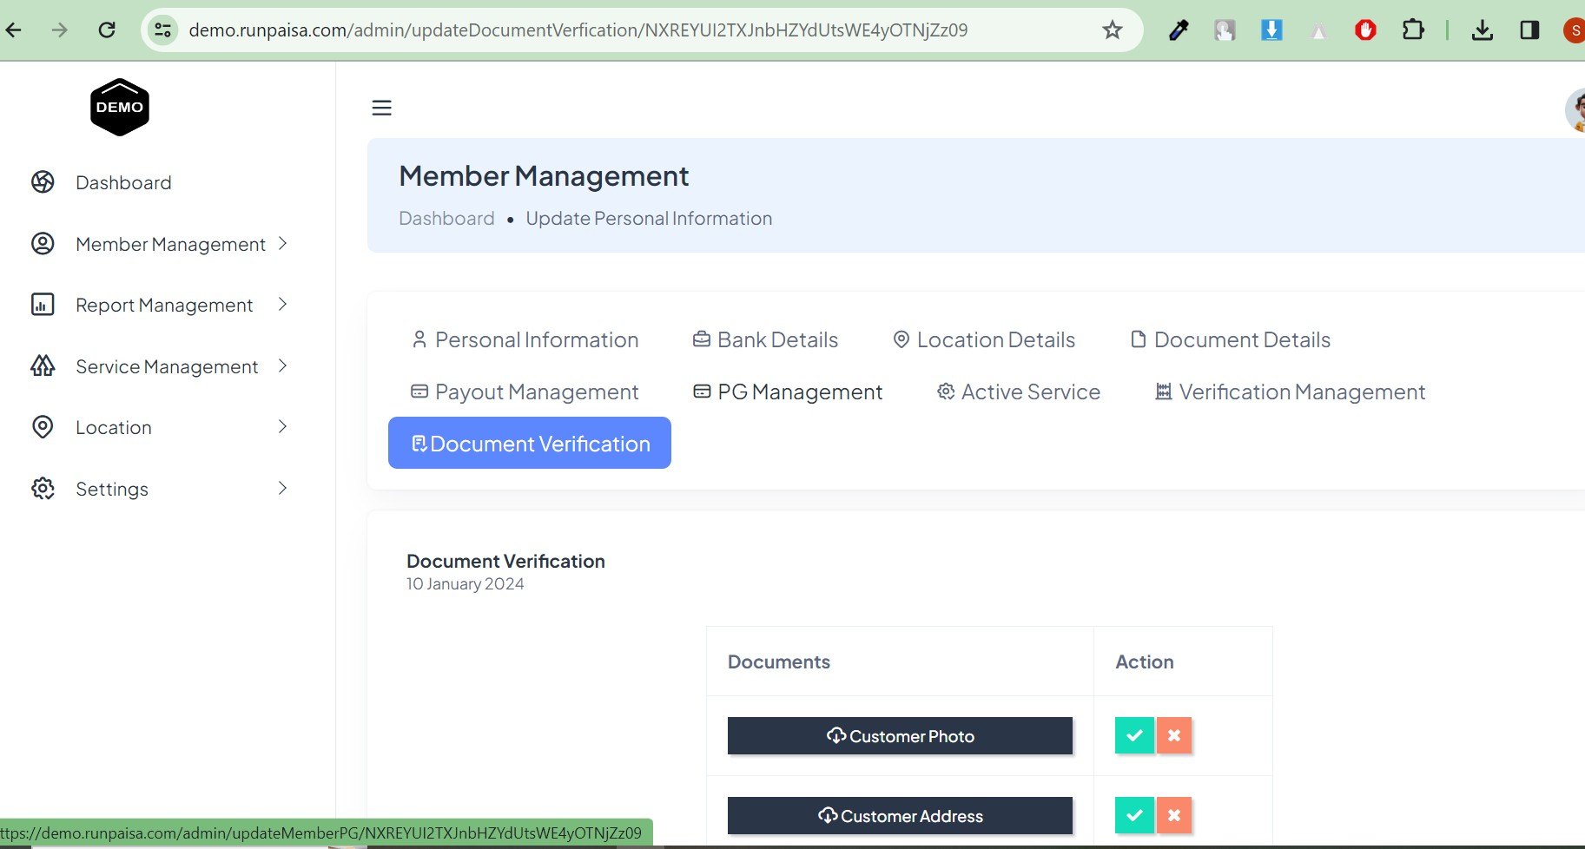Document verification

Under action check mark is to approve the document & cross mark is to reject the document.

Example:-

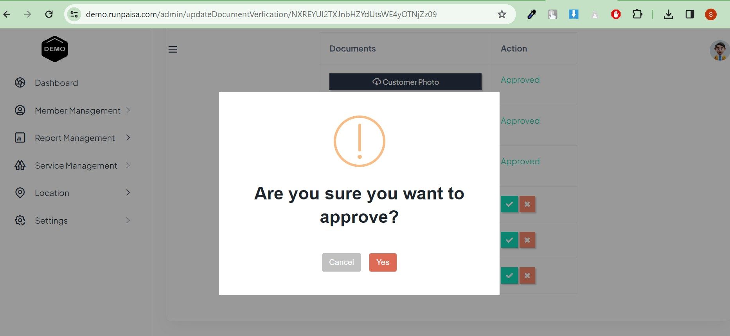If yes then document is approved by admin(by you).

  - Send money- You can send money to your distributor with this button, but you have to active the user status firstly for that you have to go check button.
    - Go back to distributor list and select the 3rd send money button

  - Check button- With the help of this button you can activate or deactivate the selected member for making the user enable to transfer money.

Go back to distributor list and active the member by clicking on last 4th check button

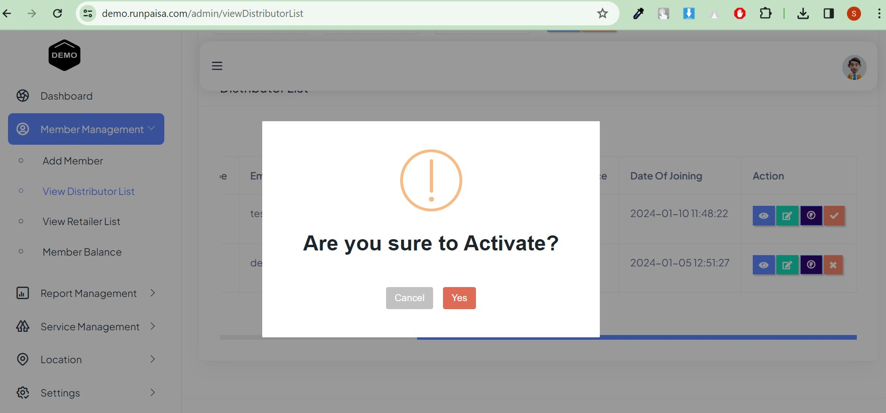
Click on yes, so that user status get active.

Go back to distributor list and select the 3rd send money button

From here you will send money to your distributor

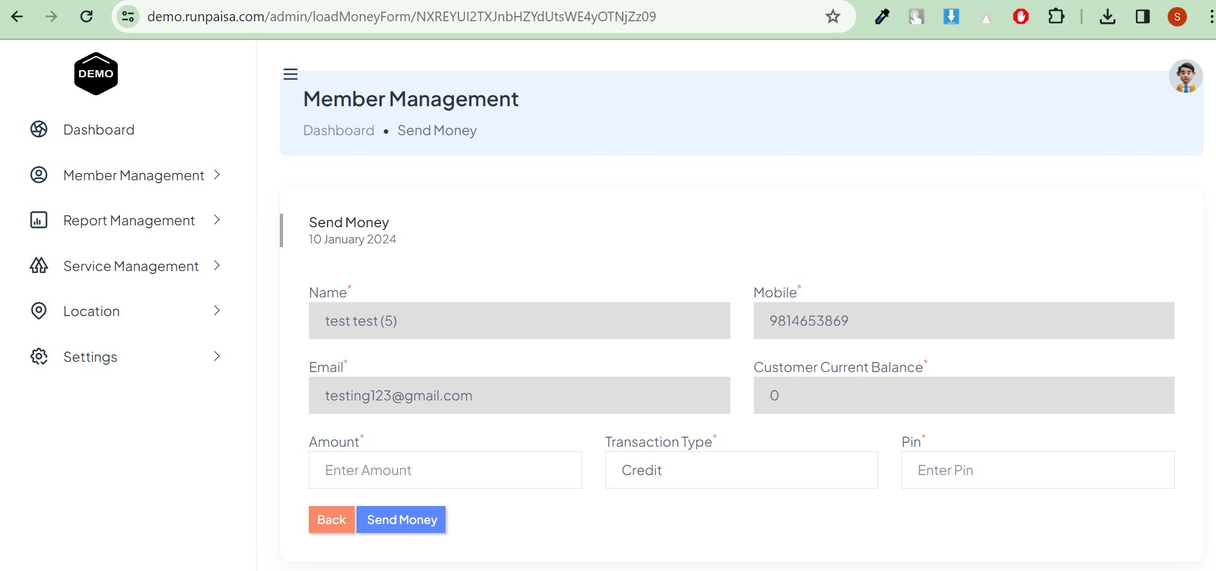

Filters
At top in filters section, You may search the member by their email id or mobile number or agent id by filtering. Please keep in mind there is no space where you are entering email/mobile no./agent id, if there will be space it could not filter.
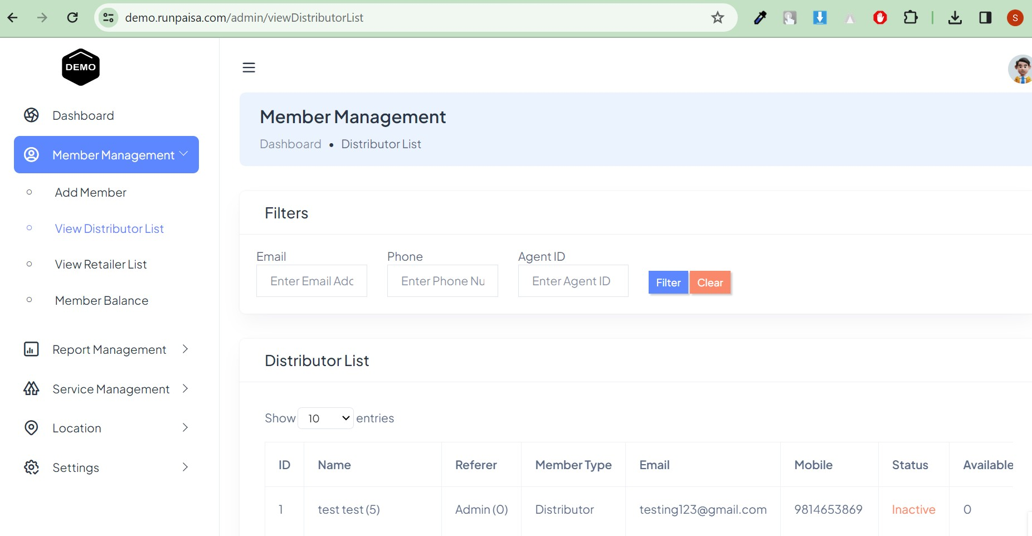

View Retailer list
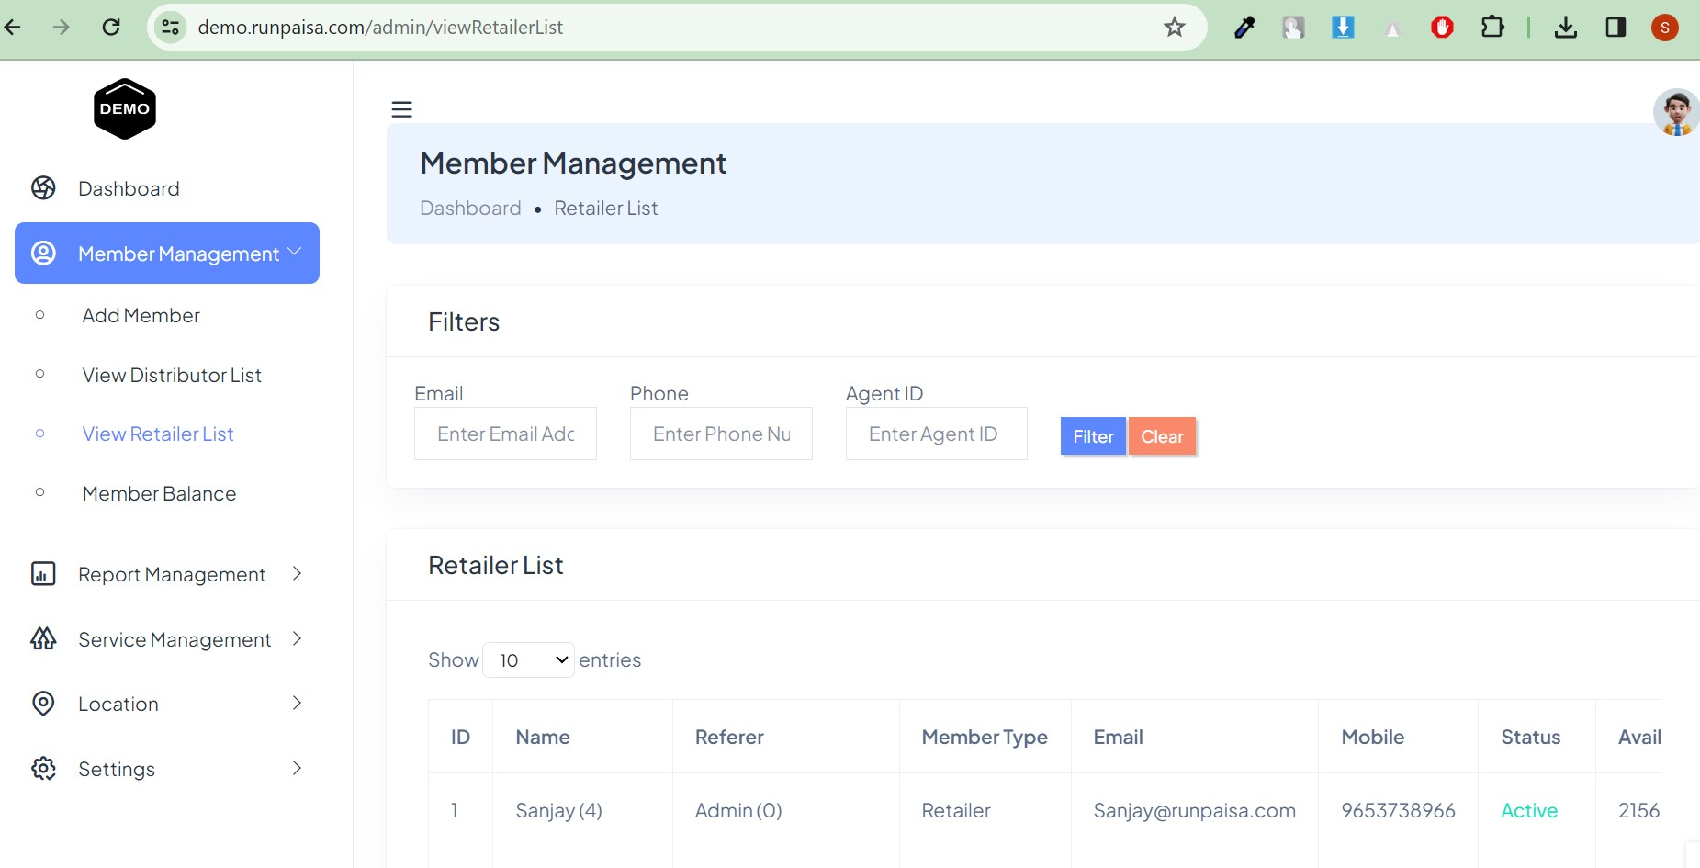Here you can see all your retailers which are created by admin and created by distributor. You can manage the retailers with the different functionalities You have to do the same as you have done in distributor list. All features which are mentioned in the distributor list are also available in retailer list as well.

Member Balance
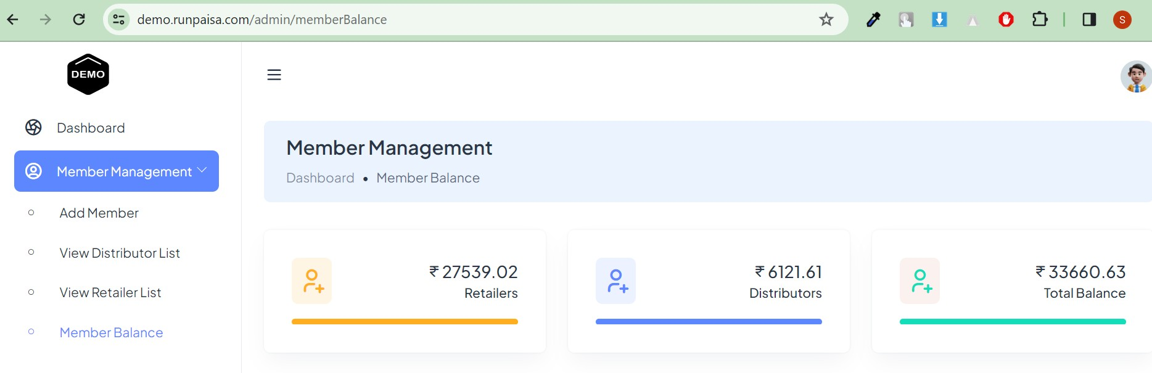In this page you can see you retailer balance, distributor balance and total balance of retailers and distributors.

REPORT MANAGEMENT
In the Report management, you can see all your reports that are mainly named as
Payout Report, TopUp Report, All Transaction Report, Verification Report , which are described in detail with their features and with example. These are the reports separately divided as follows:-

★ Payout Report
In Payout Report, all payouts which are done by distributor’s retailers and your retailers can be seen in this report. This is further divided into three reports according to months which are mentioned below:-

★ Live
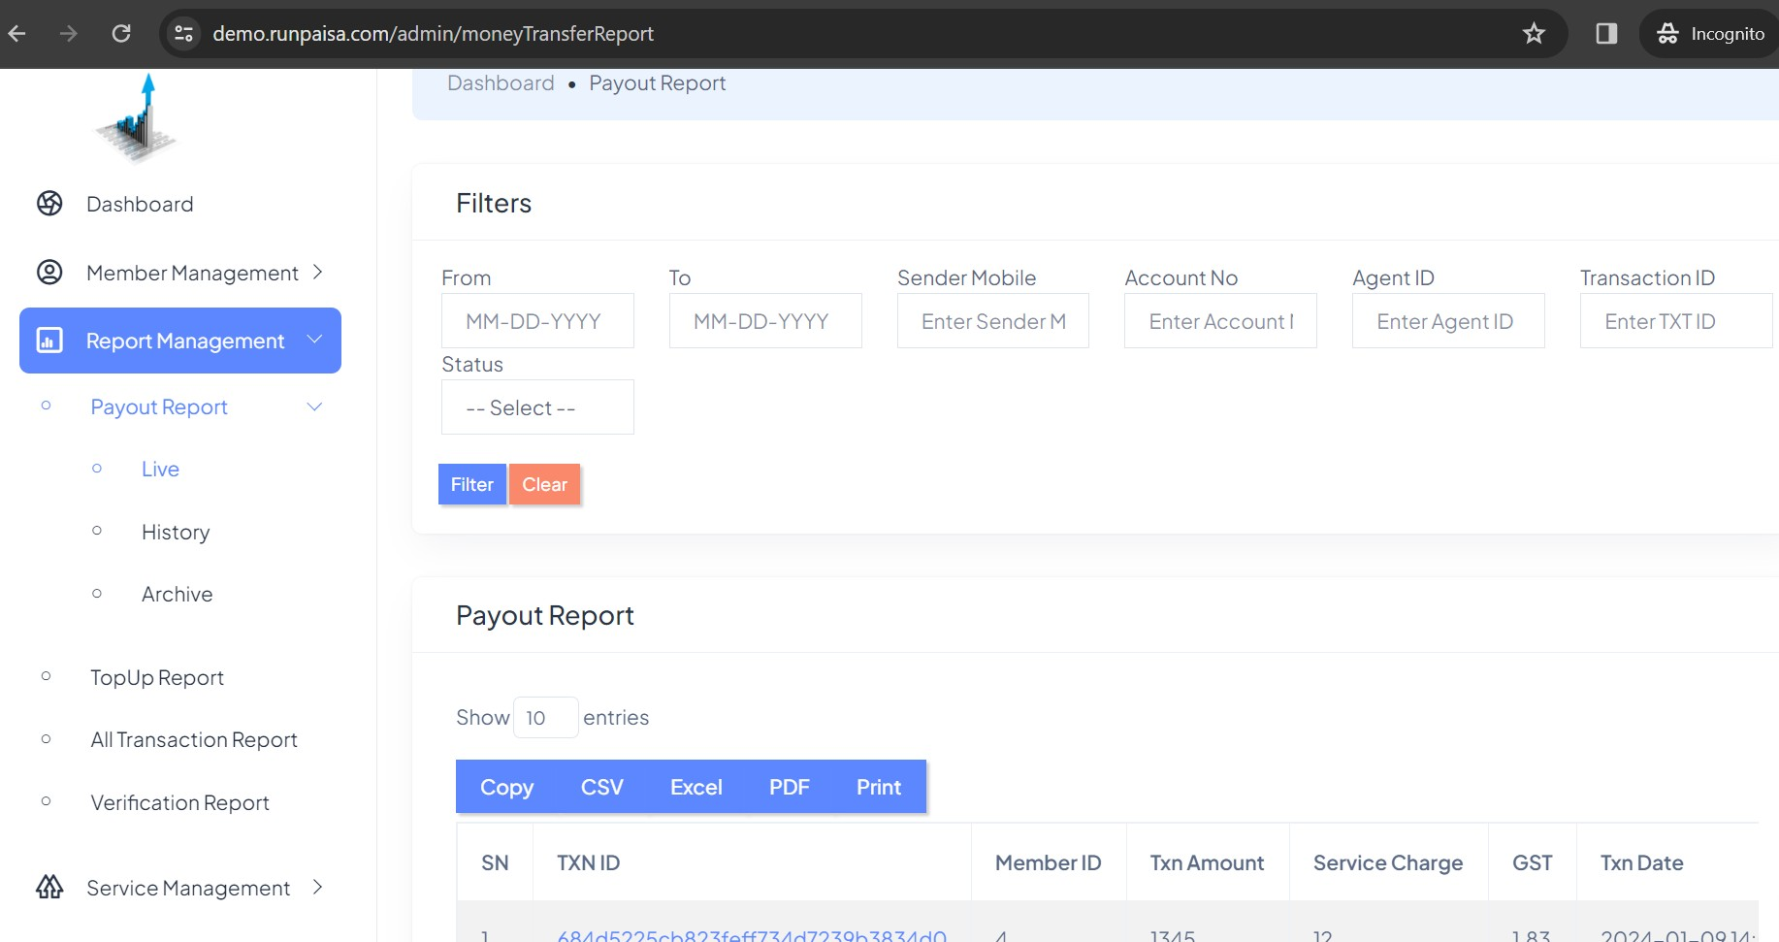In live payout report, you can see the current payout transactions done by your retailers and distributor’s retailers.

★ History
In history payout report, you can see the last one month payout transactions
done by your retailers and distributor’s retailers.

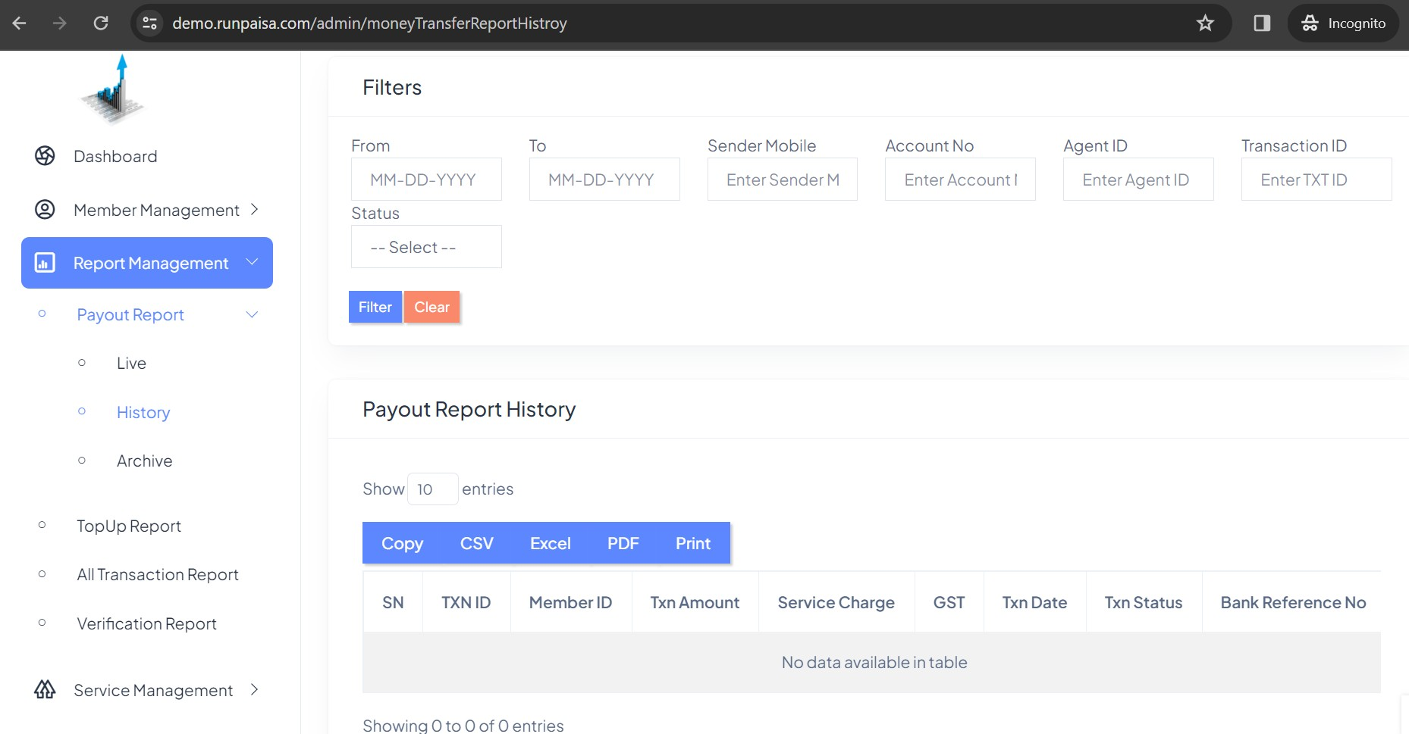

★ Archive
In archive payout report, you can see the three month payout transactions
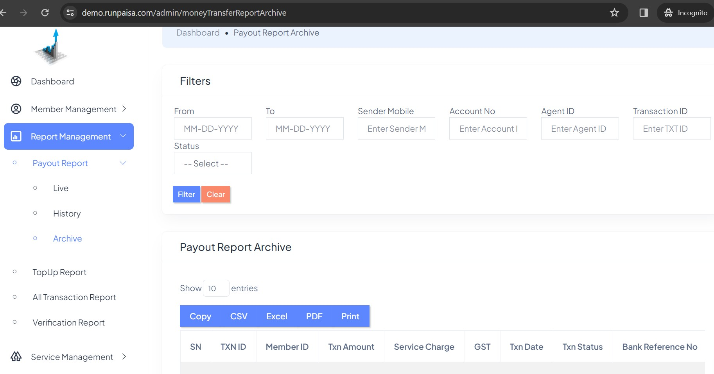done by your retailers and distributor’s retailers.

★ TopUp Report
In TopUp Report, all wallet top up which are done by distributor’s retailers and your retailers can be seen in this report. This is further divided into three reports according to months which are mentioned below:-

★ Live
In live Topup report, you can see the current TopUp transactions done by your distributors, retailers and distributor’s retailers.
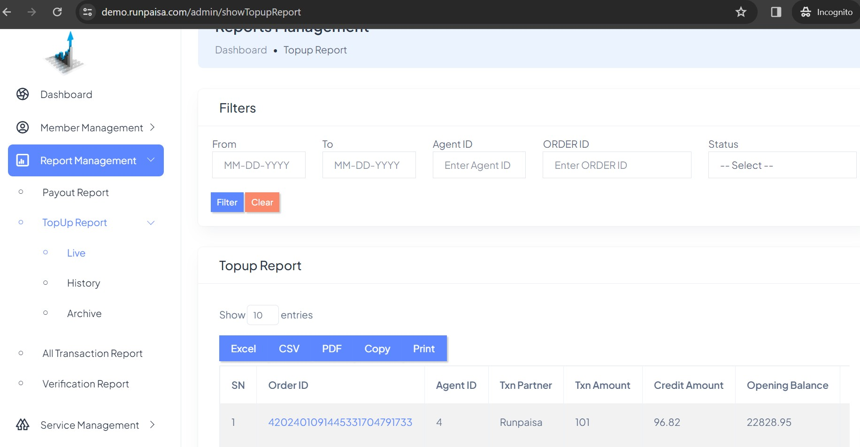

★ History
In history topup report, you can see the last one month topup transactions
done by your distributors,retailers and distributor’s retailers.

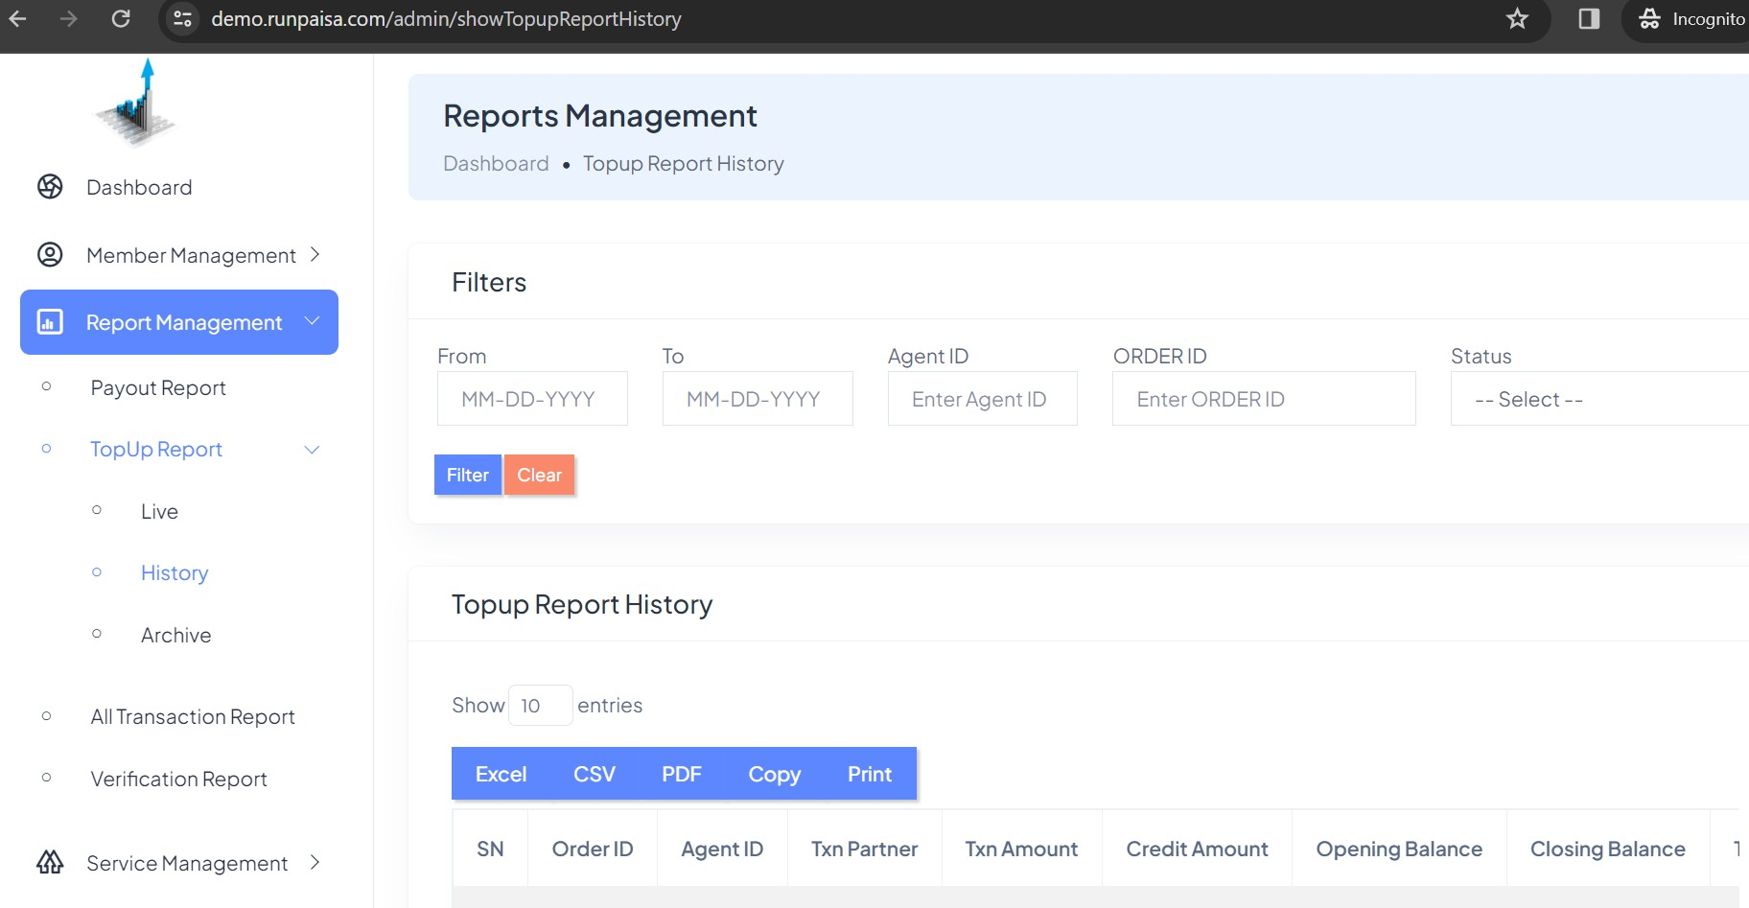

★ Archive
In archive topup report, you can see the three month topup transactions done by your distributors, retailers and distributor’s retailers.
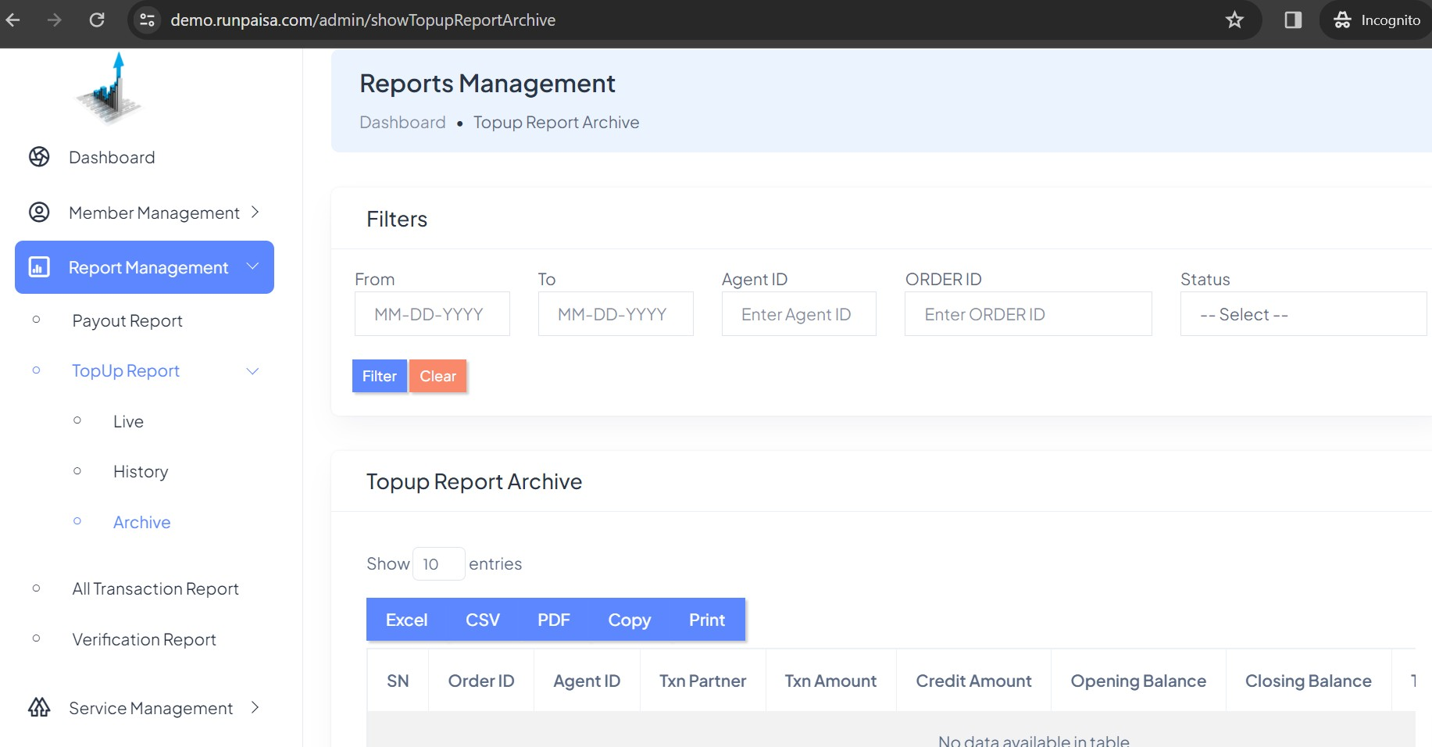

★ All Transaction Report
In All Transaction Report, all Transaction whether it is wallet top up or payouts which are done by distributors, distributor’s retailers and your retailers can be seen in this report. This is further divided into three reports according to months which are mentioned below:-

★ Live
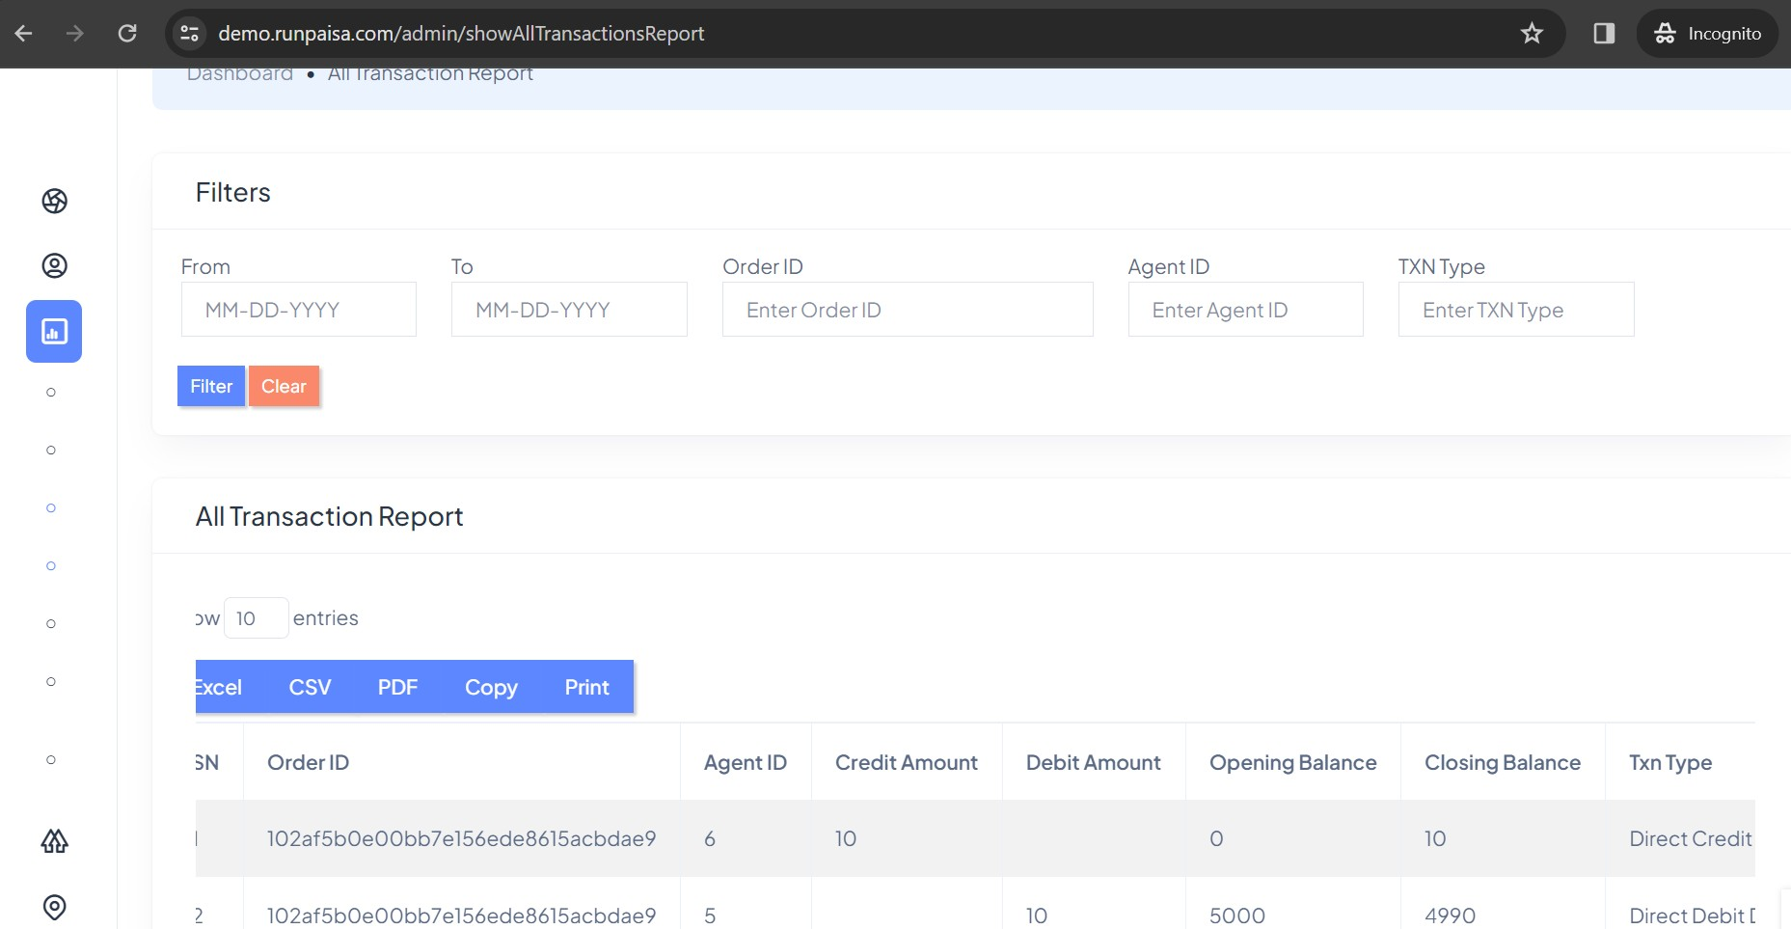In live all transaction report, you can see the current All transactions done by your distributors, retailers and distributor’s retailers.

★ History
In history all transaction report, you can see the last one month all transactions done by your distributors,retailers and distributor’s retailers.

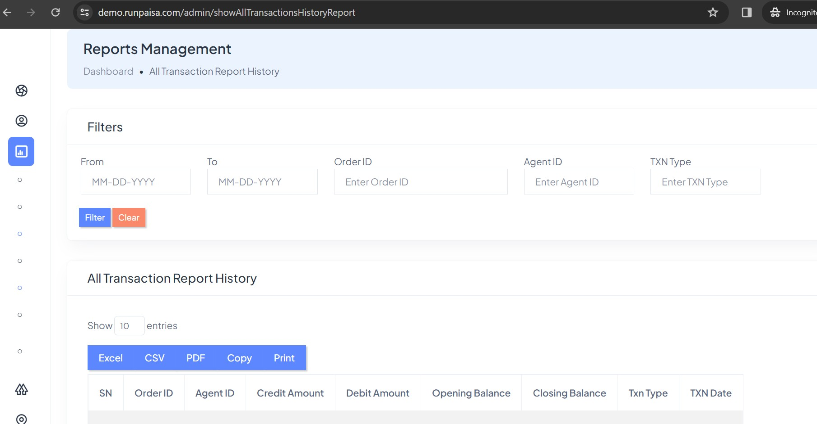

★ Archive
In archive all transaction report, you can see the three month all transactions
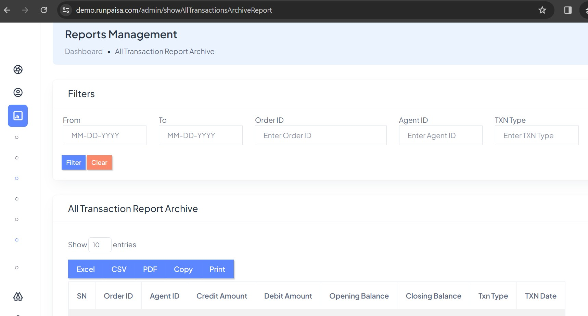done by your distributors, retailers and distributor’s retailers.

★ Verification Report
This verification report is for all verification done by admin and retailers on PAN, GST, BIN, BAV etc.
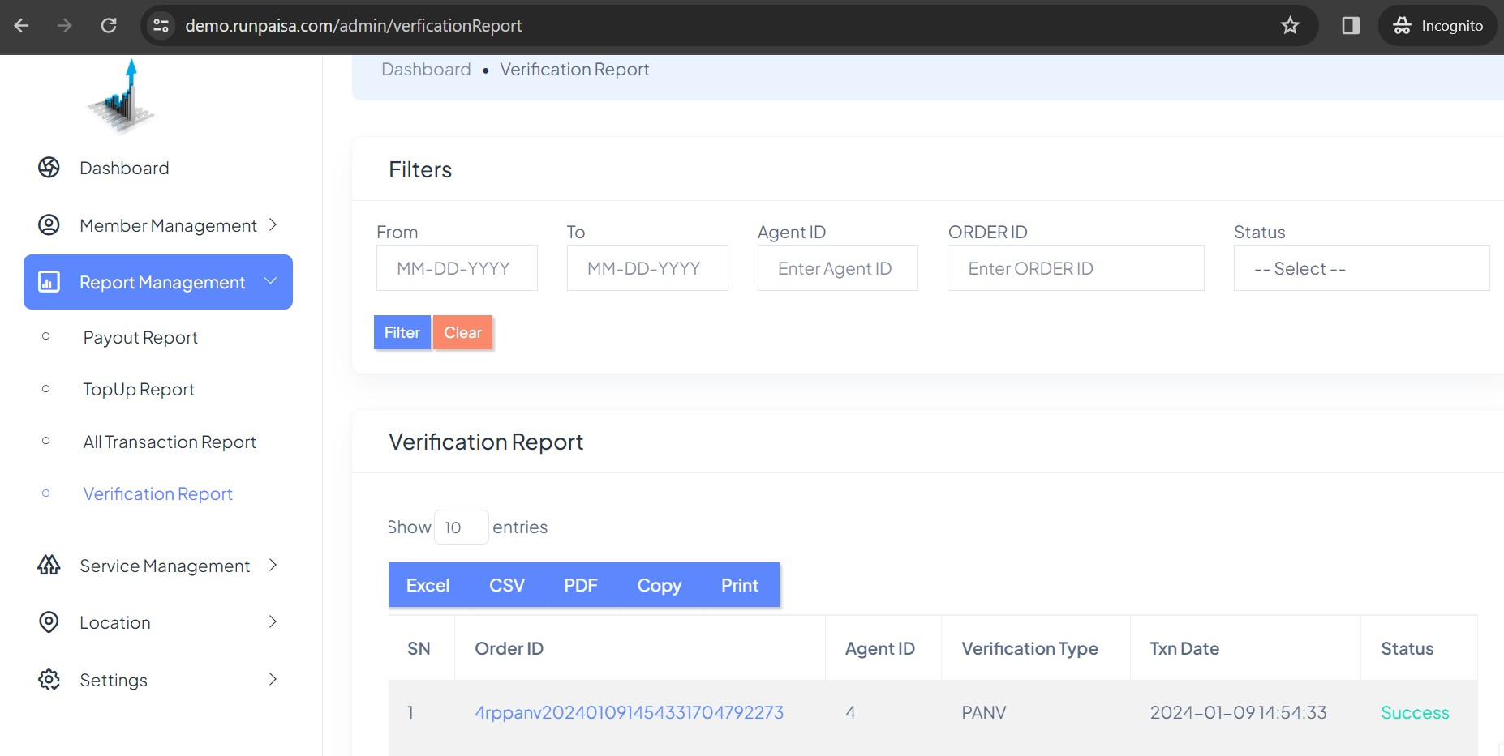

SERVICE MANAGEMENT
In Service Management, you will see all the services, like payout, PG, BAV, PAN, BIN, GST etc..Under this Active Services section in which you have the option to activate or deactivate particular service. If you activate one service then all yours will be eligible for that service otherwise they couldn’t use that service.

Active Services
Here is the example for making any service active or de-active for all users.

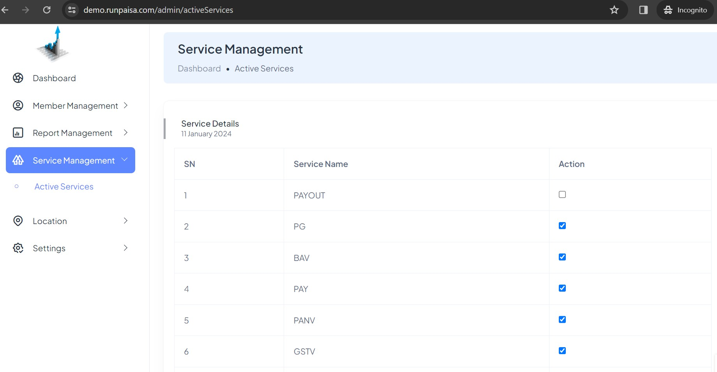

LOCATION
In Location, there is dropdown menu having two section one for Manage States and other for Manage Cities, from where you can add, edit or delete the city in any state.

Manage States
In this page you can search your State at State field by filtering. You can add State by click on add State button at top right.

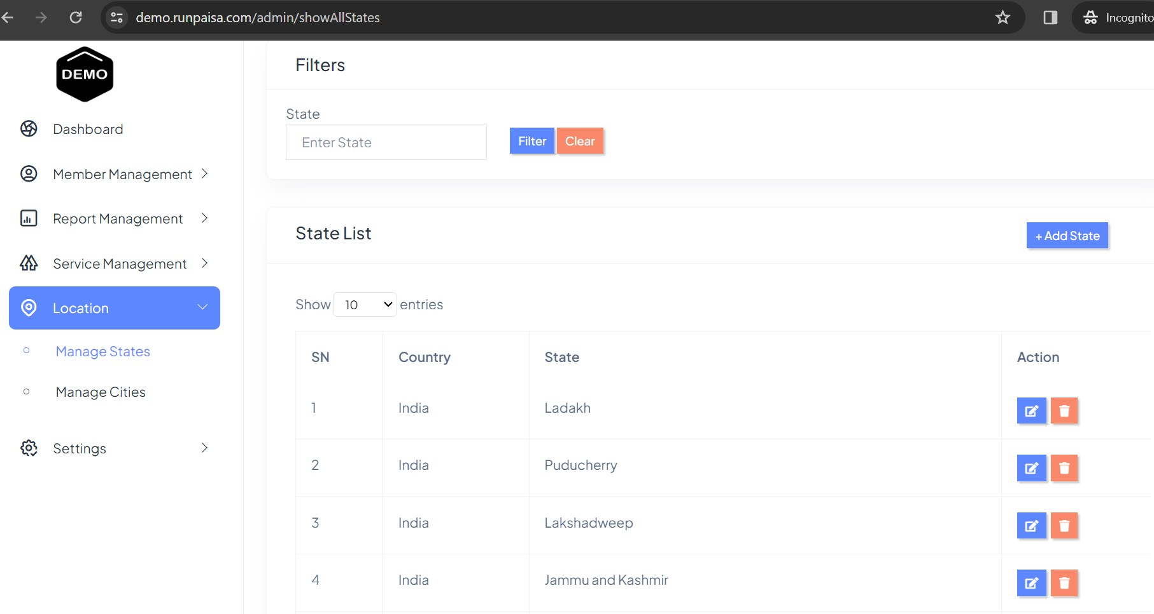
When you Click on Add State button you get this pop up to add State
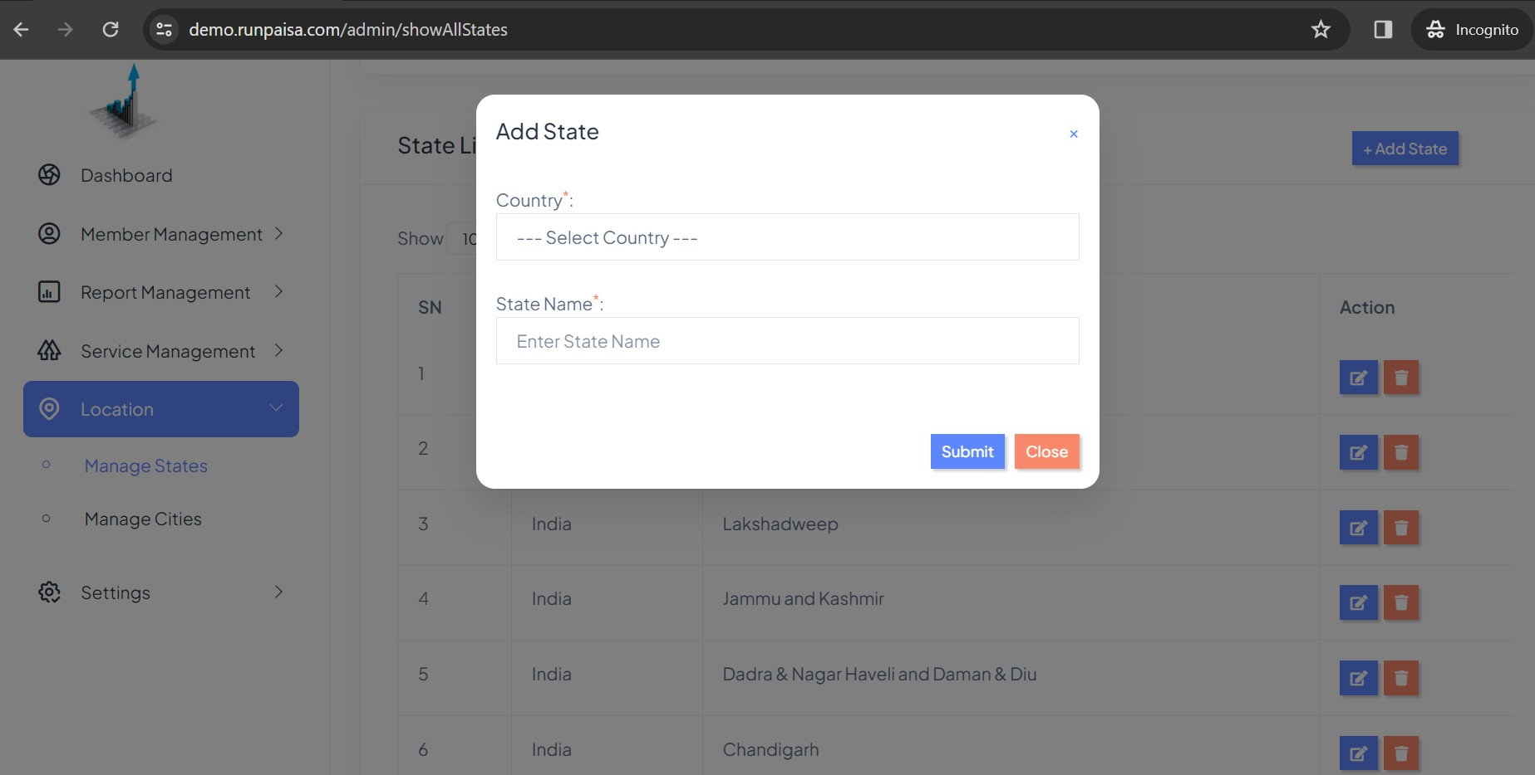
You can also edit the State if any spelling Mistake, when you click on edit button under Action column, you get pop up like this where you can change

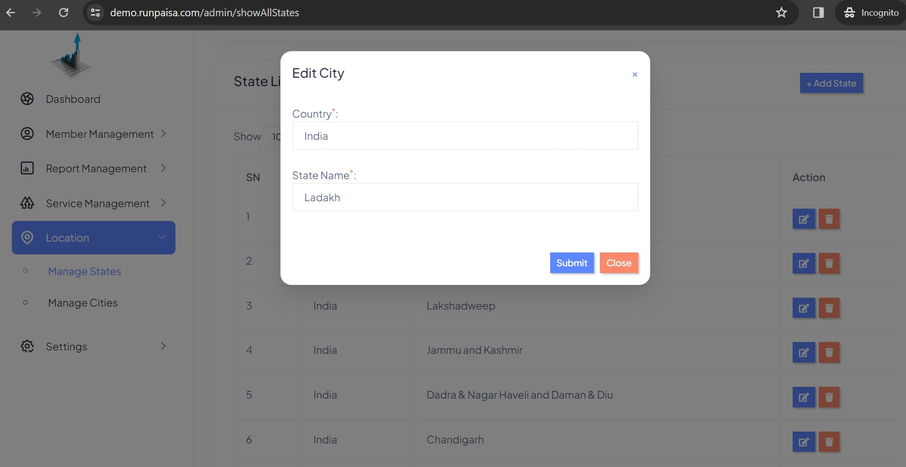
You can delete the State if it gets doubled in table by clicking on delete button under action column. You get the alert like below image
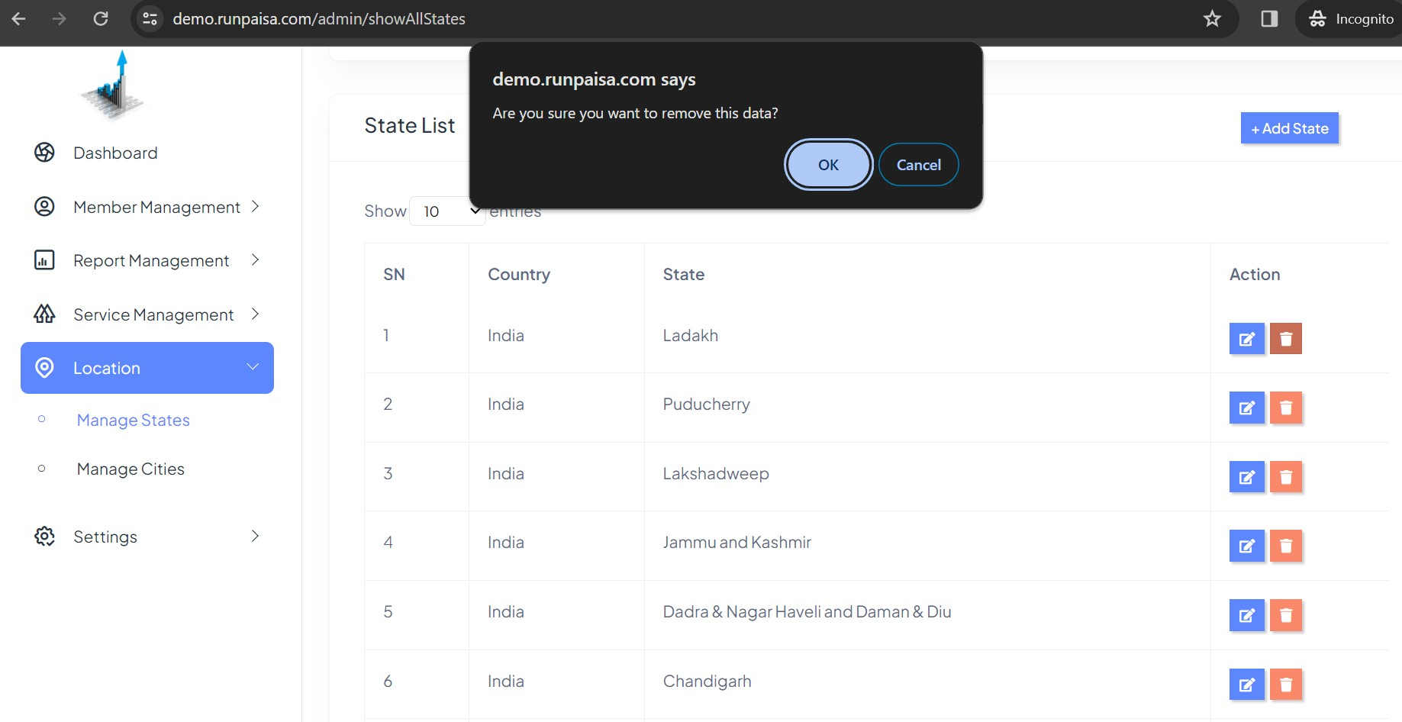

Manage Cities
In this page you can search your State at State field and City from city field by filtering.
You can add City by click on Add City button at top right.

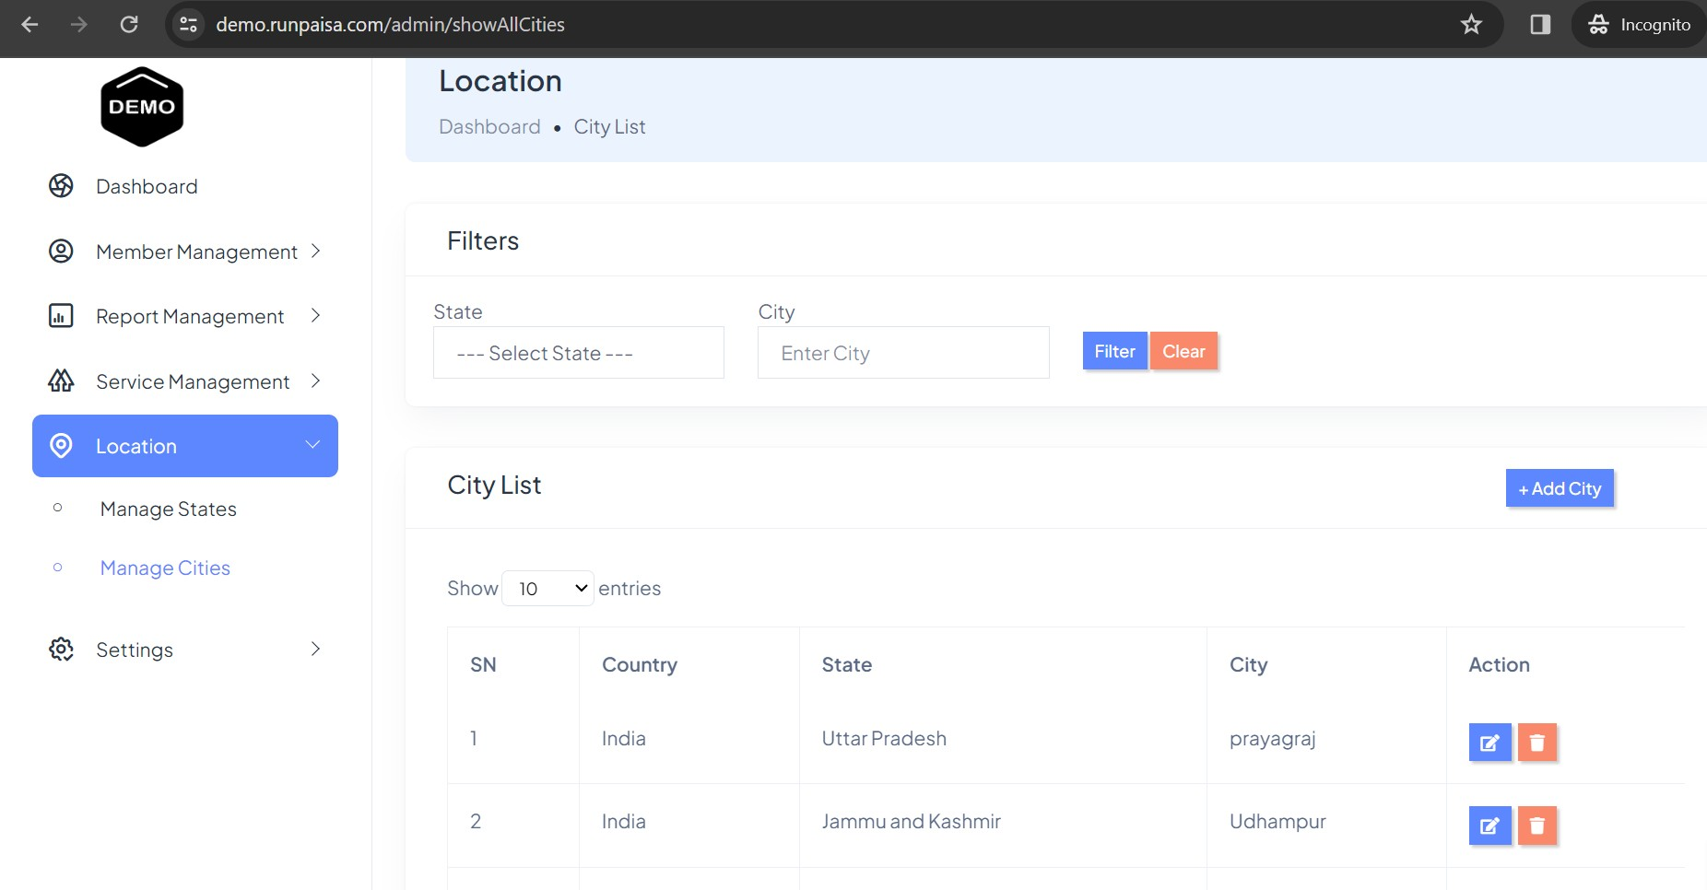
When you Click on Add City button you get this pop up to add City in your State if It is not in the list.
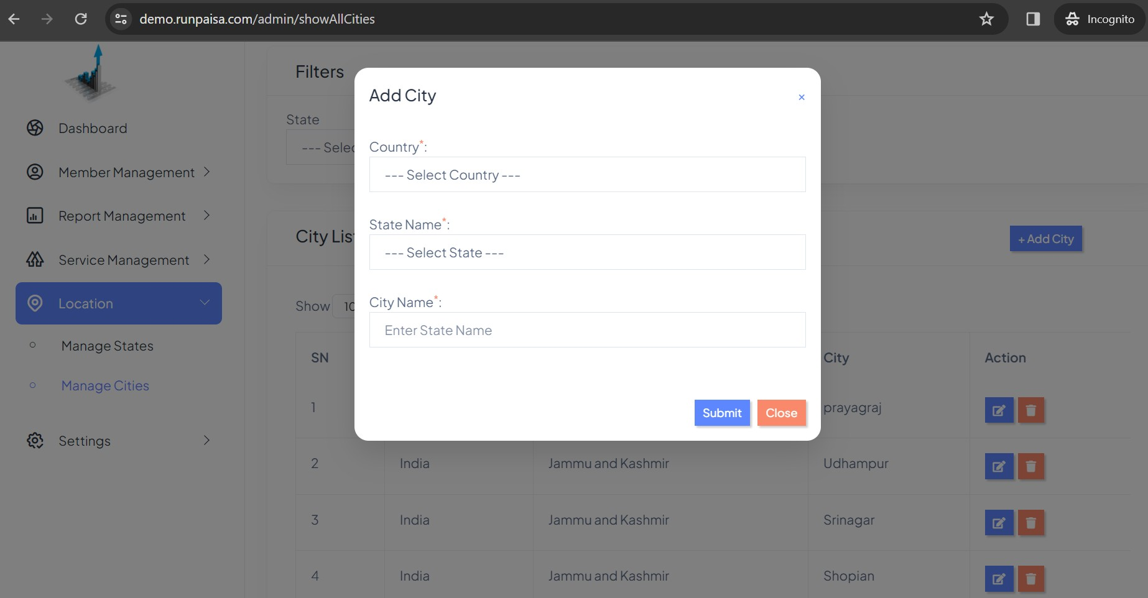

You can also edit the State & City if any spelling Mistake, when you click on edit button under Action column, you get pop up like this where you can change

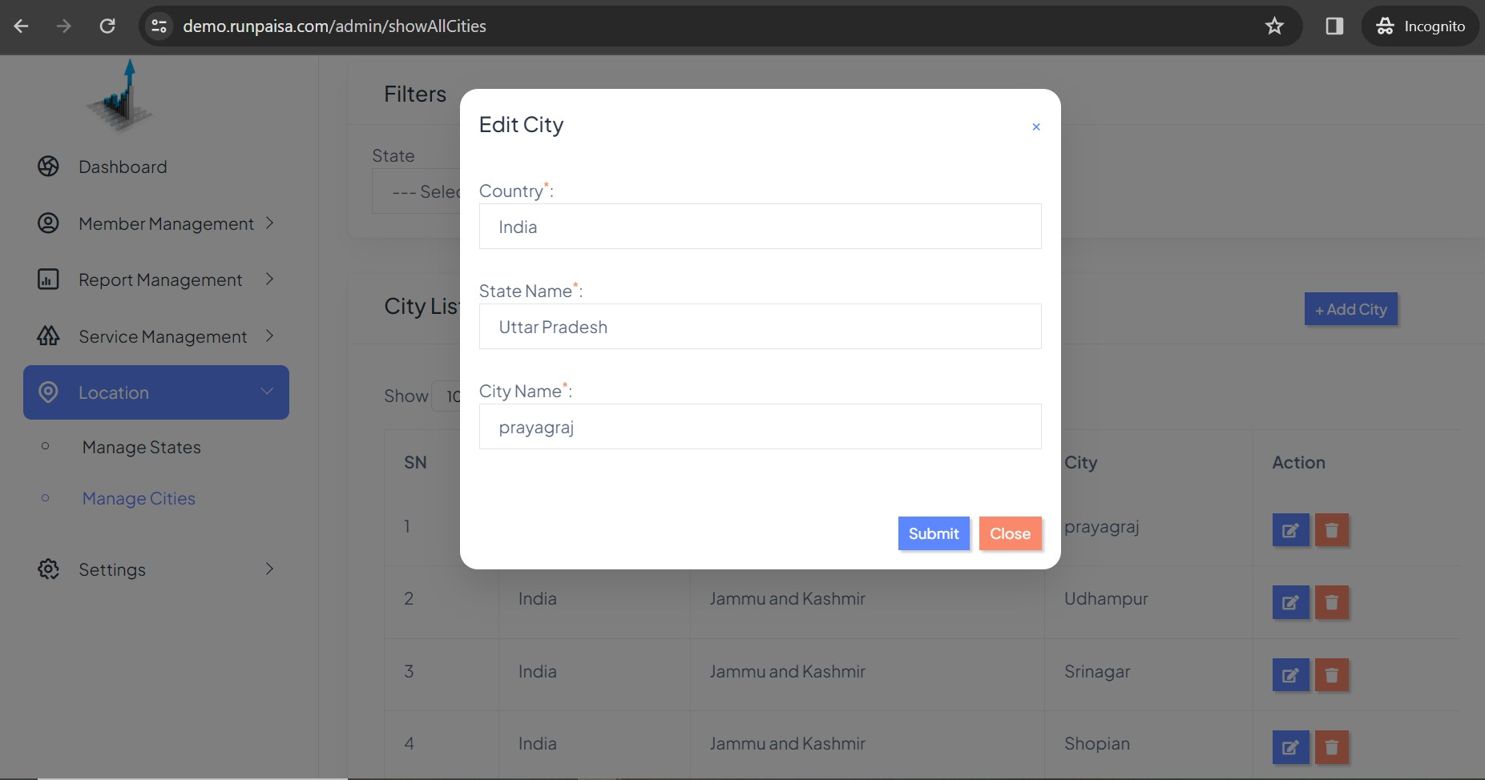

You can delete the State or City if it gets doubled in table by clicking on delete button under action column. You get the alert like below image
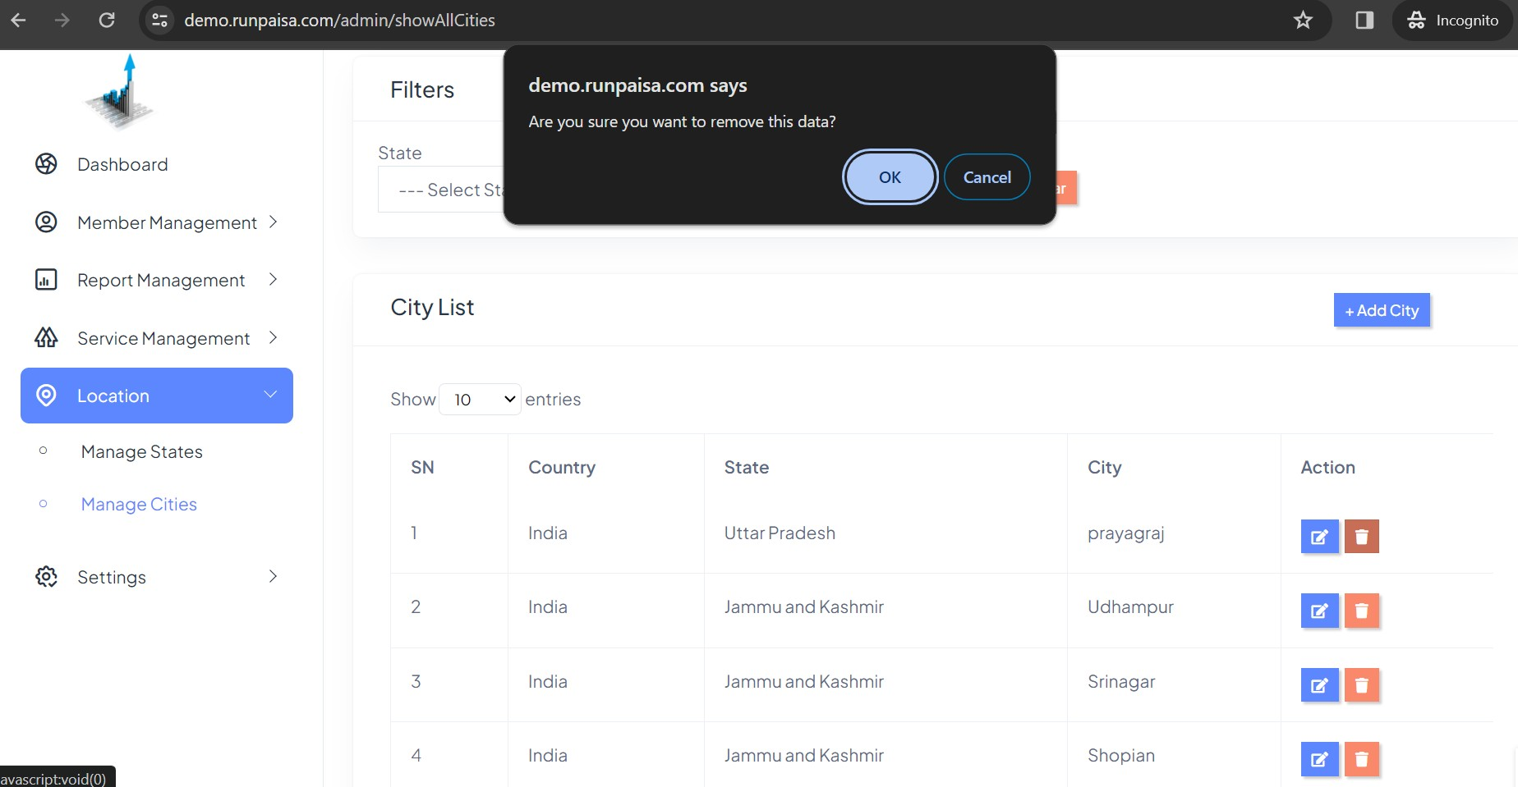

SETTINGS
In Settings, you have different features for making changes in your profile, API charges, Config Charges, Settlement day, logo change. There is a dropdown menu for different sections which are as following:-
★ Manage Banks
★ Api Charge Master
★ Config Charge master
★ Settlement After Day
★ Profile
★ Application Settings
★ Logout

All these sections are described below with more explanation:-

Manage Banks
In manage banks you can search the bank with their name or with IFSC at the top of page in filter section.
You can add, edit or delete the bank from the table list. ADD Bank-
  - Click on Add bank
  - 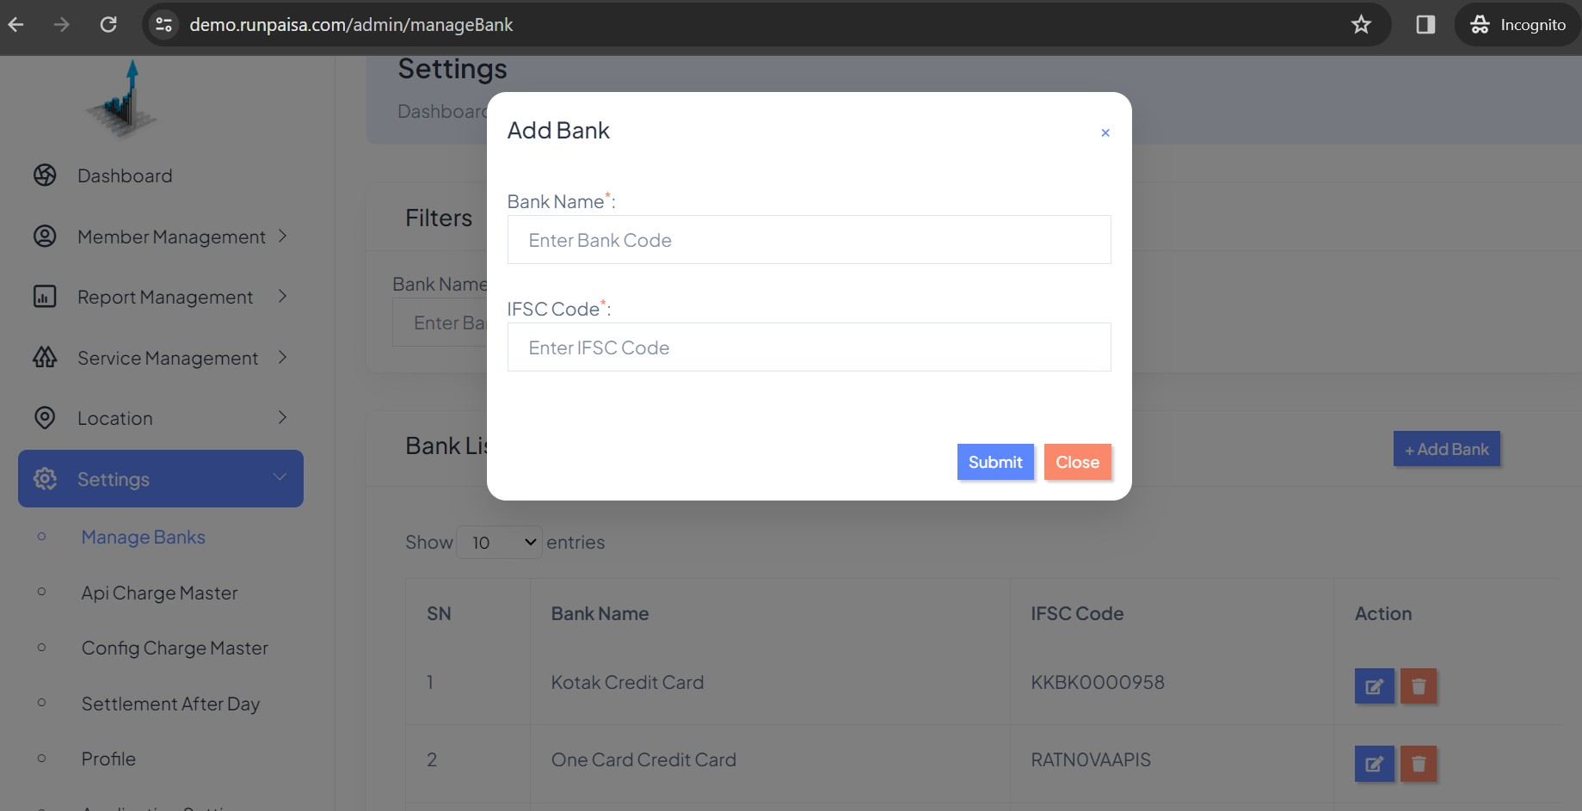Get the pop up

EDIT Bank-
    - Click on Edit Button under Action column
    - 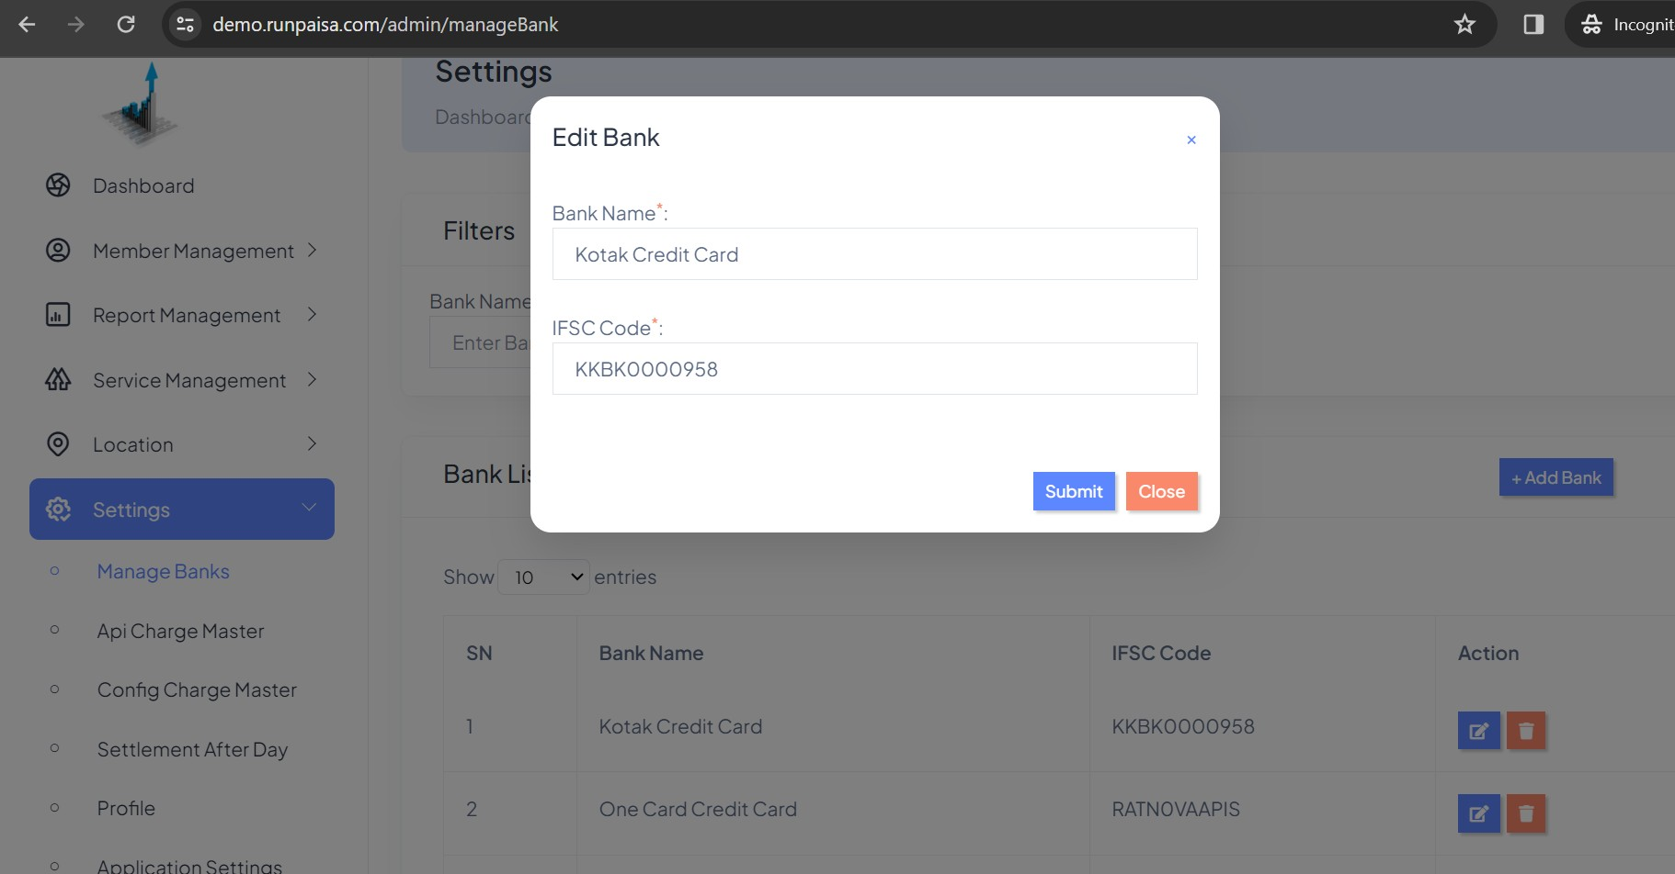You get the pop up

DELETE Bank-
      - Click on delete button
      - 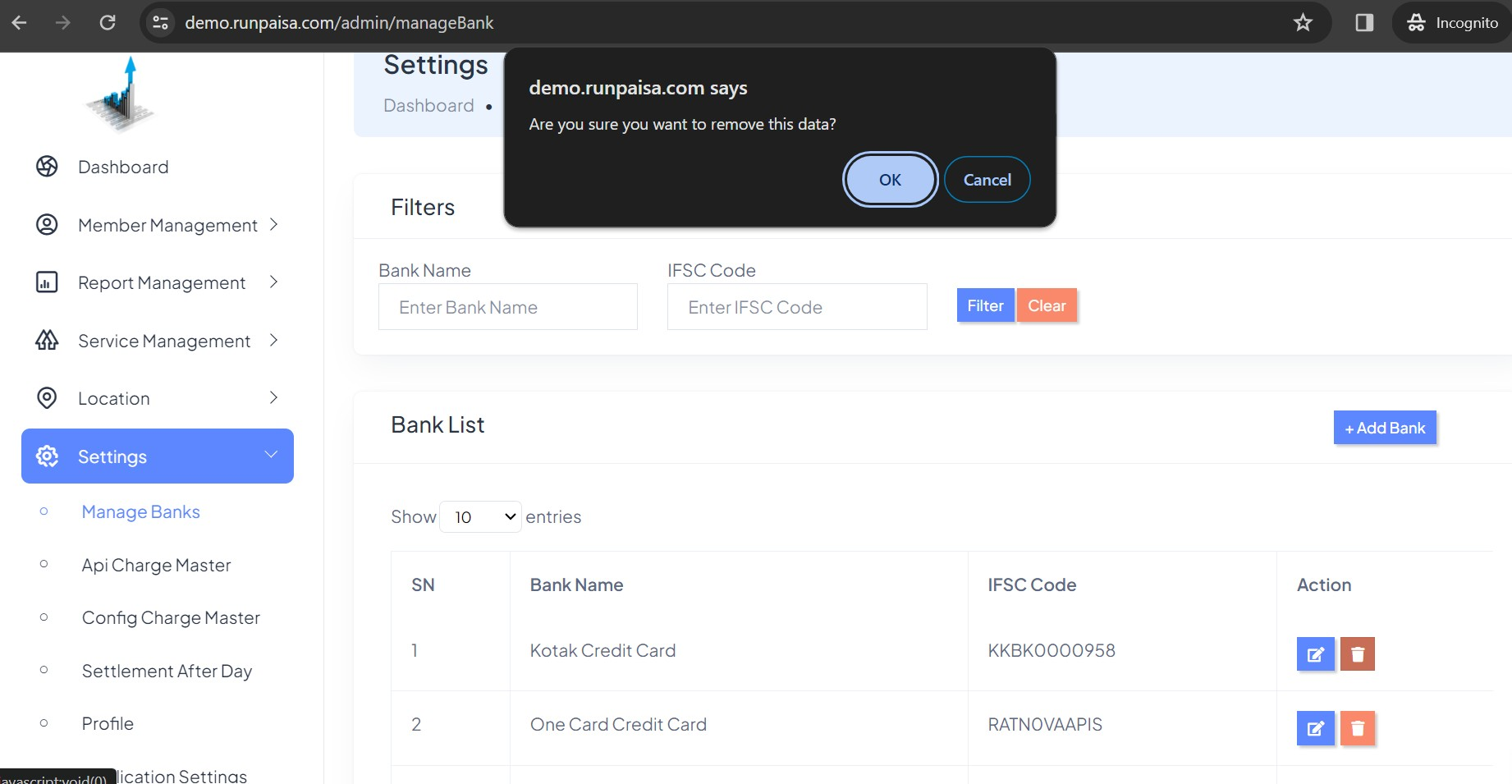You get the alert like below given example

Api Charge Master
In Api Charge master page,
- PG Charge:- To set the PG Api Charges like charges for using credit card, debit card, corporate card, amex, diner, wallet, net banking, UPI
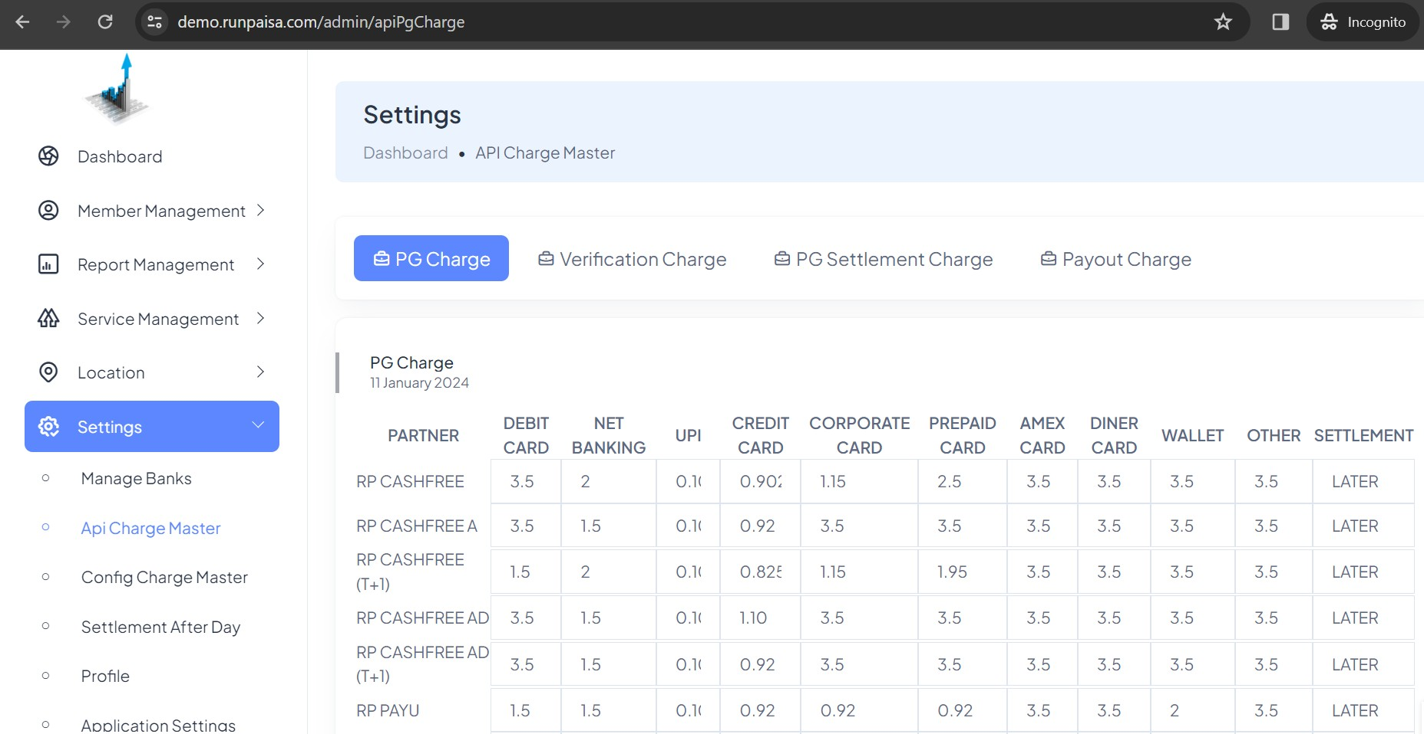
- 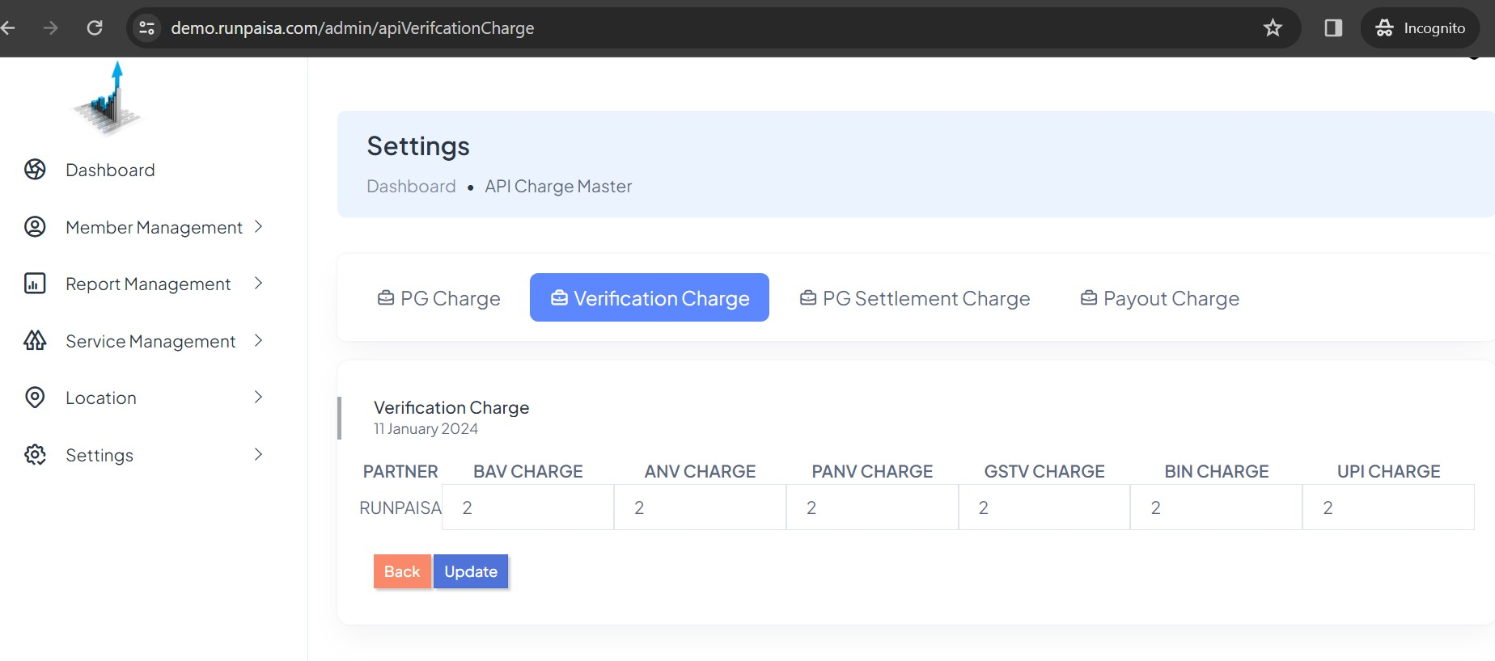Verification Charge:- These are the charges for different verifications

- PG Settlement Charge:-
These are the Api PG Settlement Charges which are editable.

- 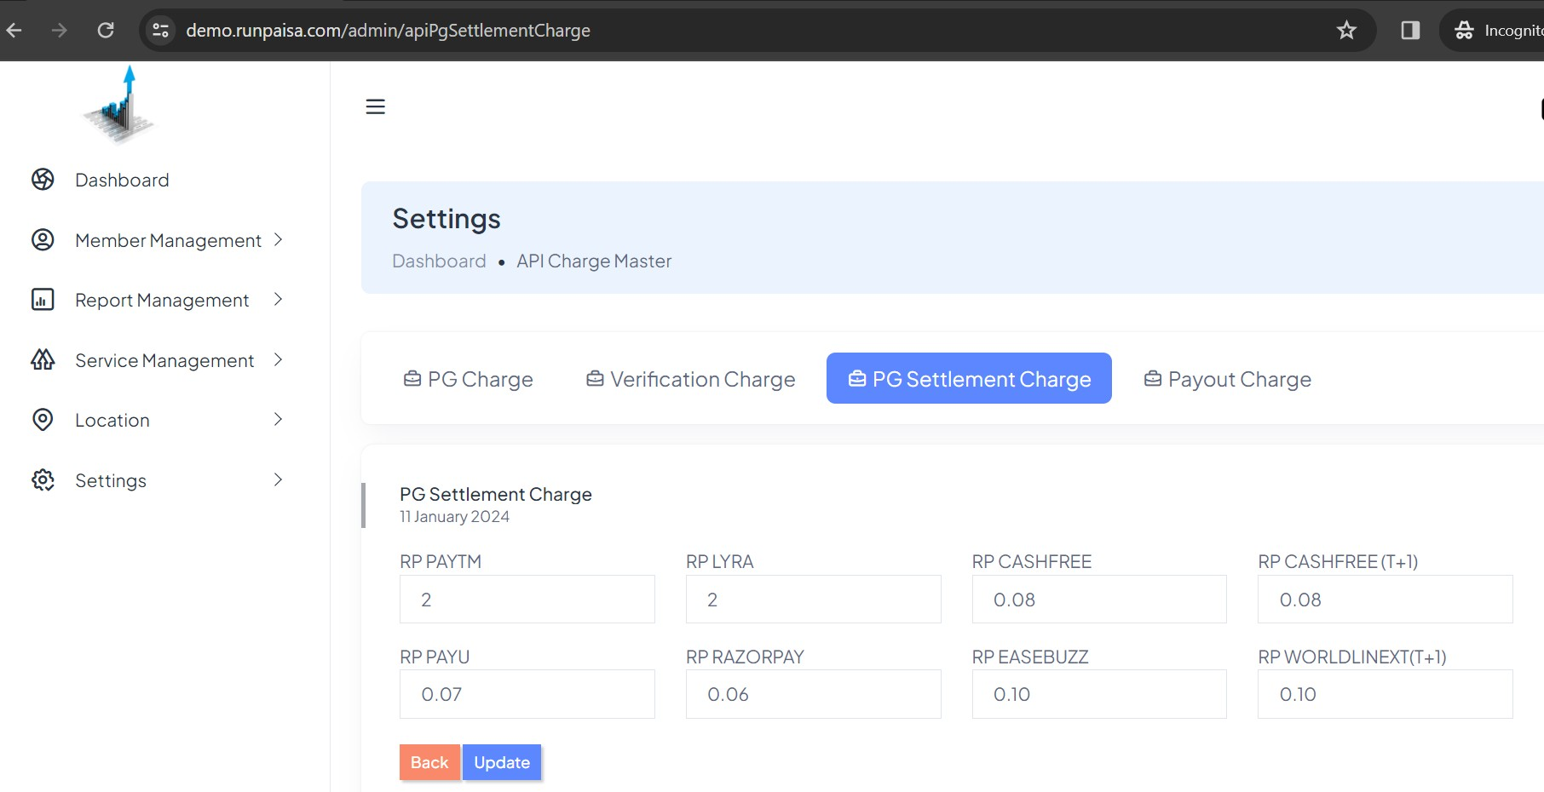Payout Charges:-
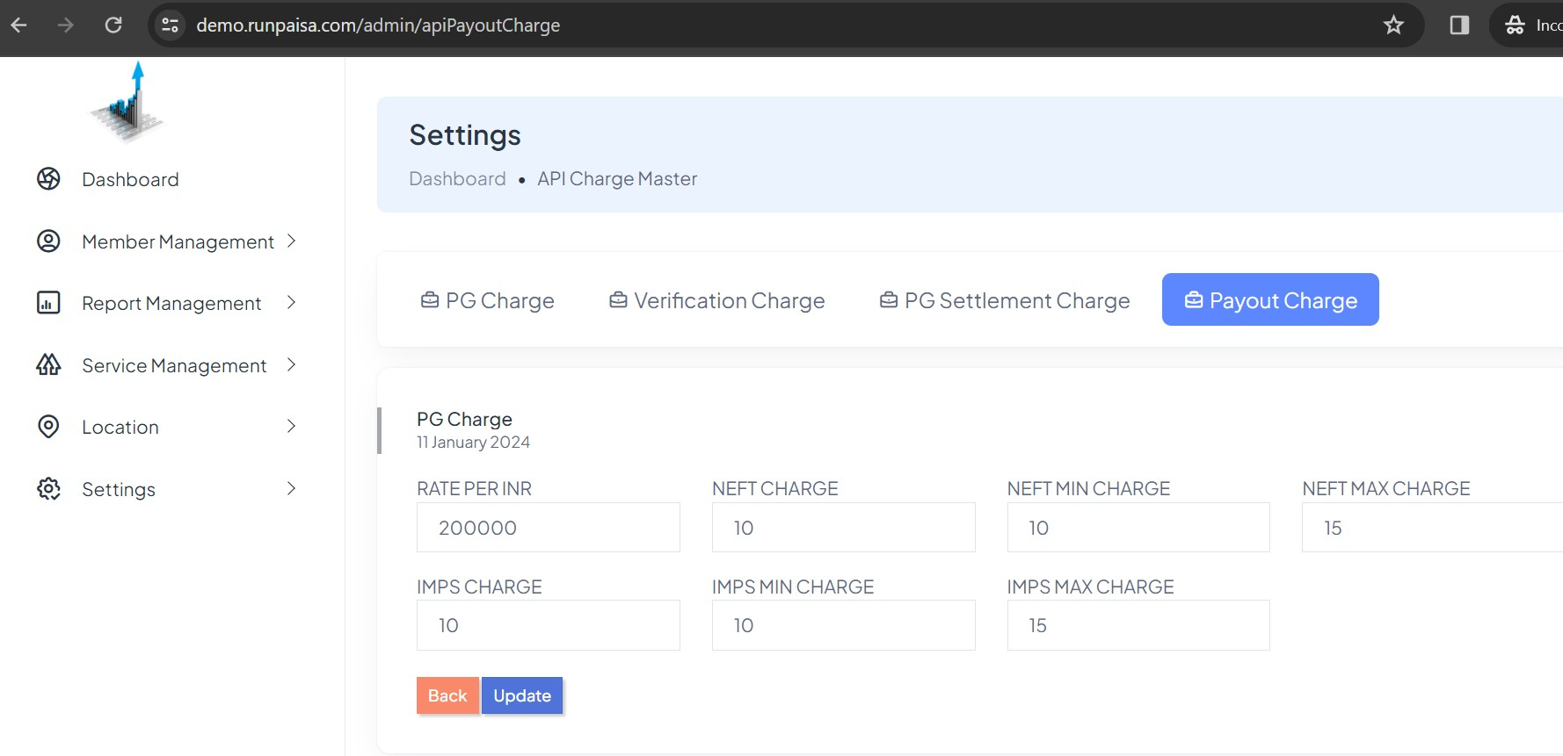These are the charges for payout transactions while using NEFT and IMPS which can be changed.

Config Charge Master
In Config Charge master page,
  - PG Charge:- To set the PG Api Charges like charges for using credit card, debit card, corporate card, amex, diner, wallet, net banking, UPI.

  - 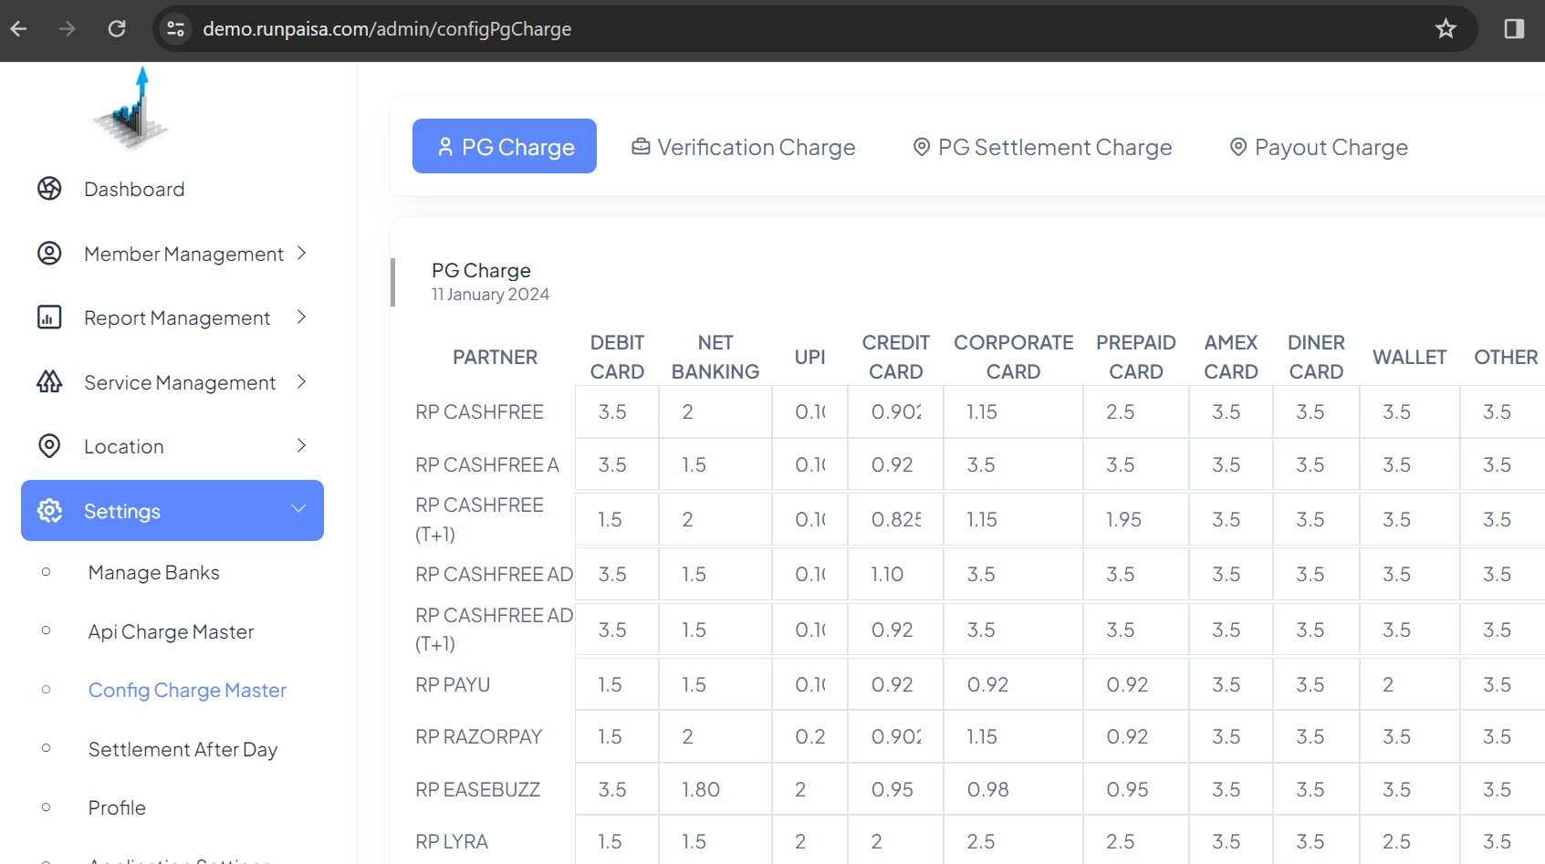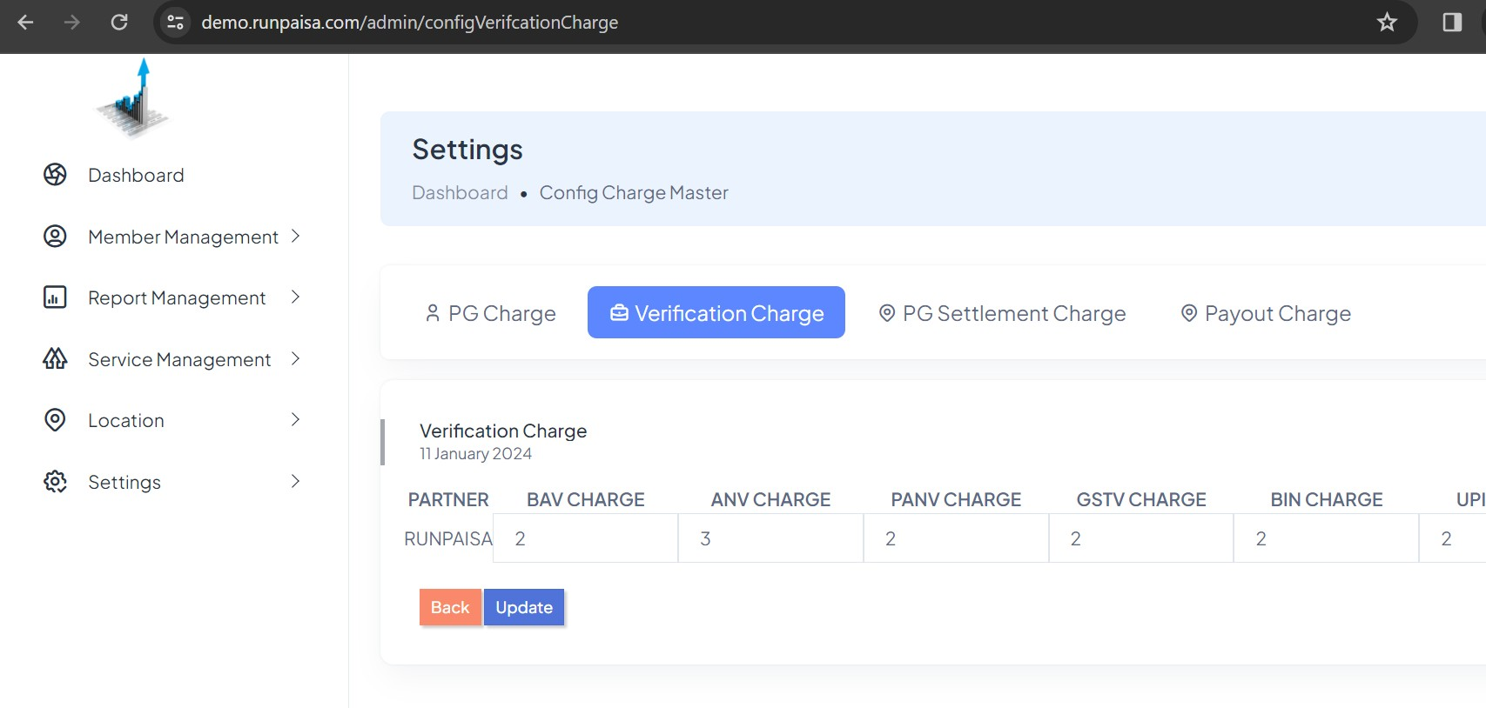Verification Charge:- These are the charges for different verifications

  - PG Settlement Charge:-
These are the Config PG Settlement Charges which are editable.

  - 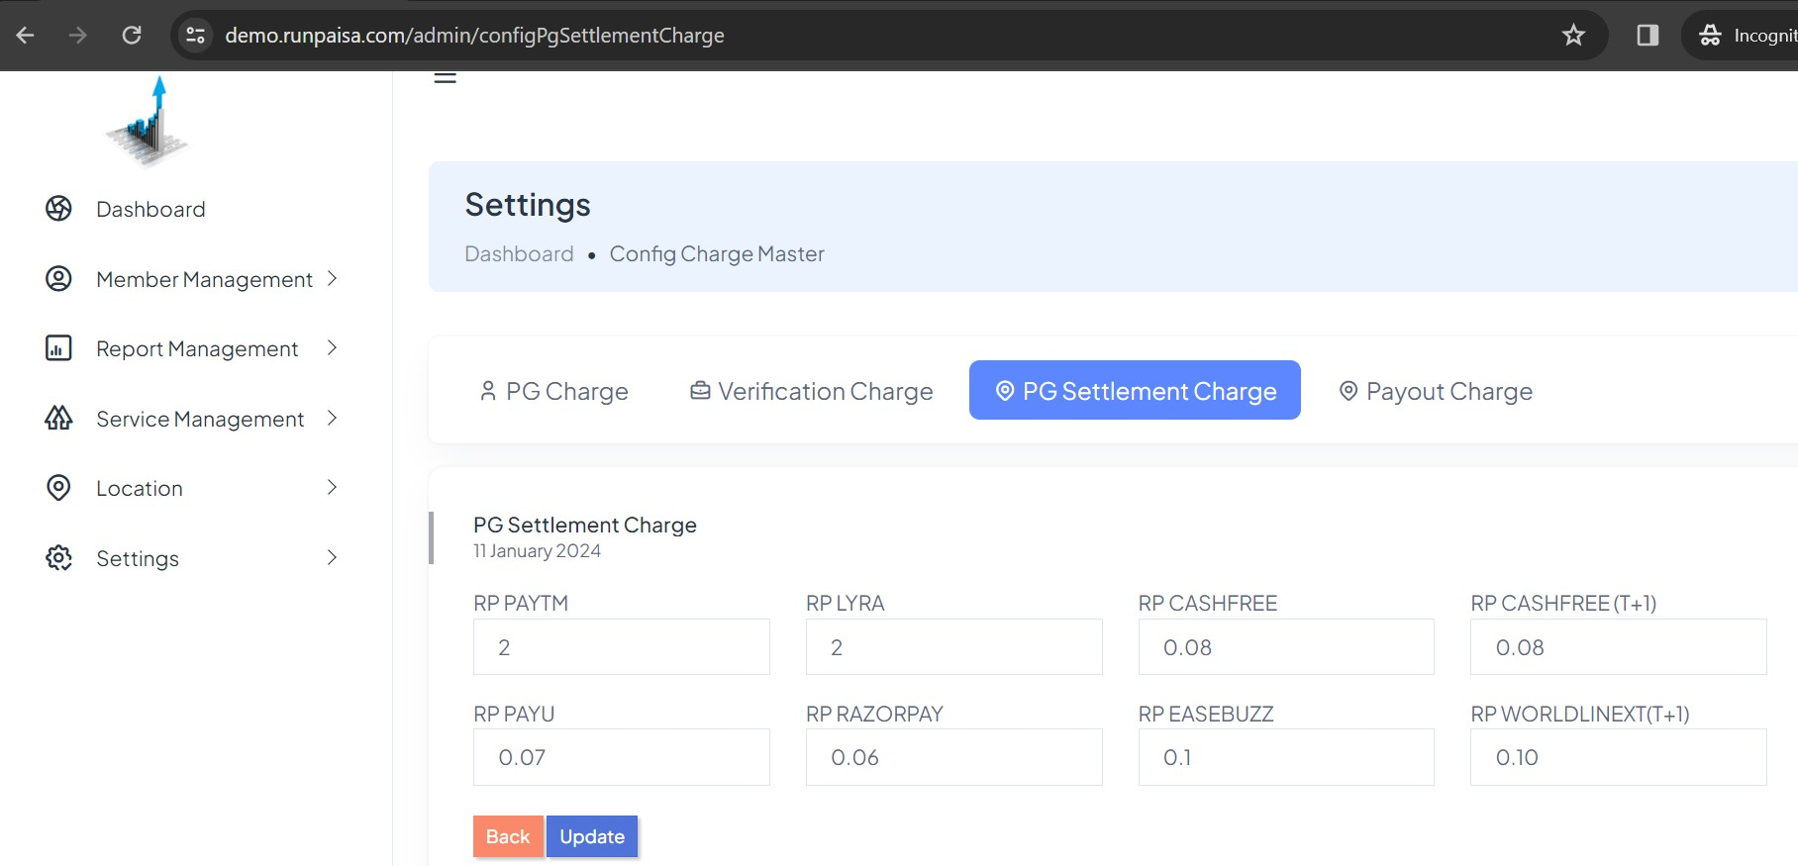Payout Charges:-
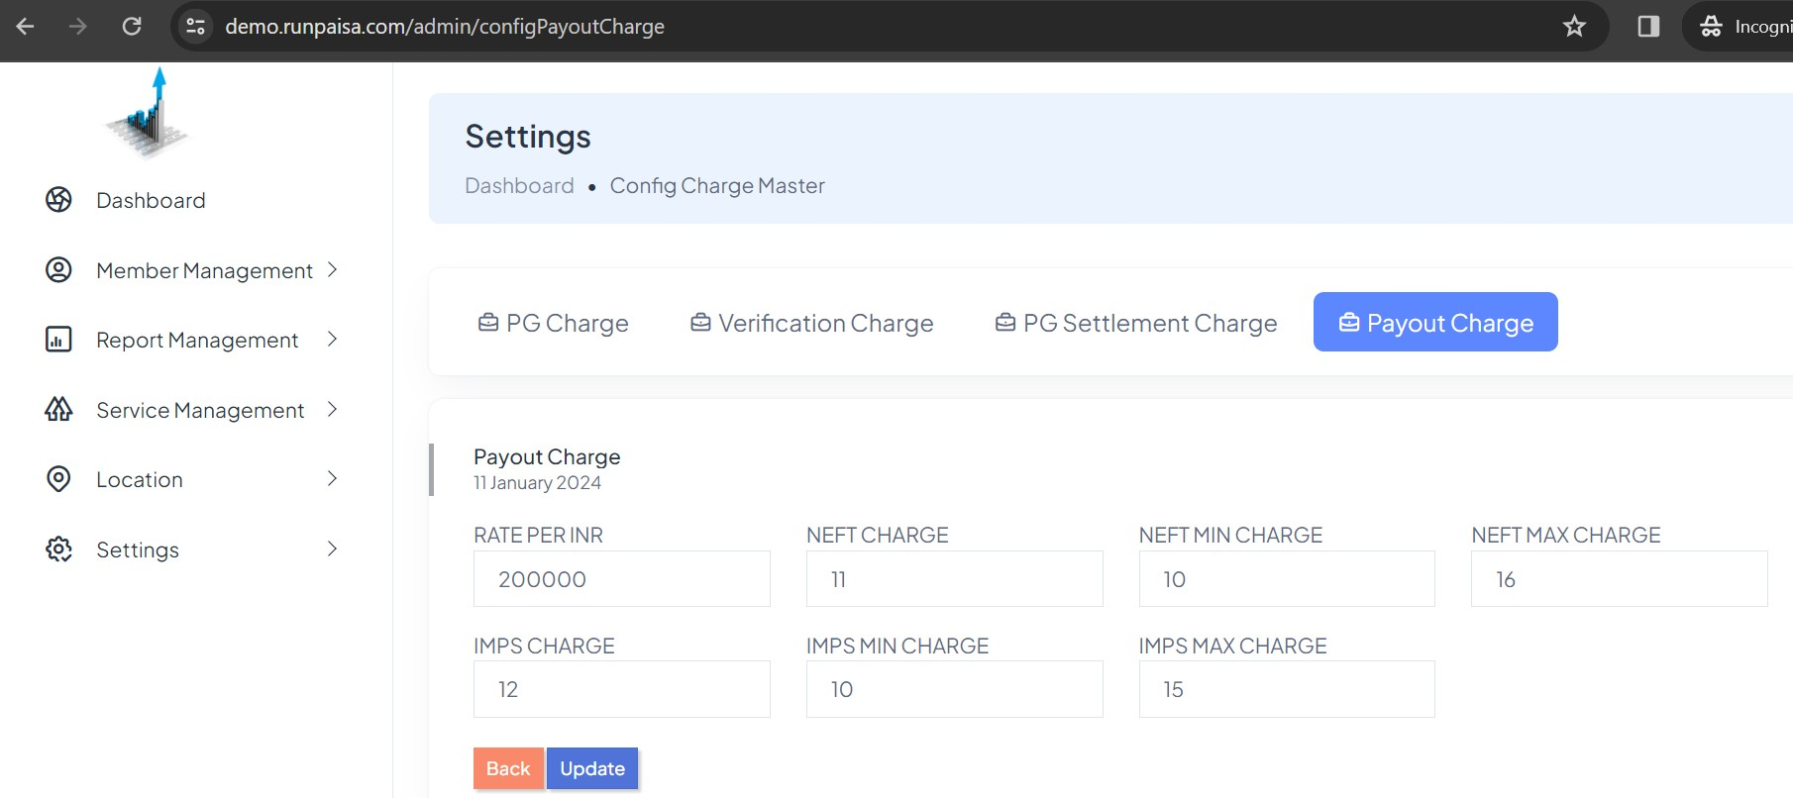These are the charges for payout transactions while using NEFT and IMPS which can be changed.

Settlement After Day
In this you active the Settlement day, in how much days particular PG transaction should be settle.

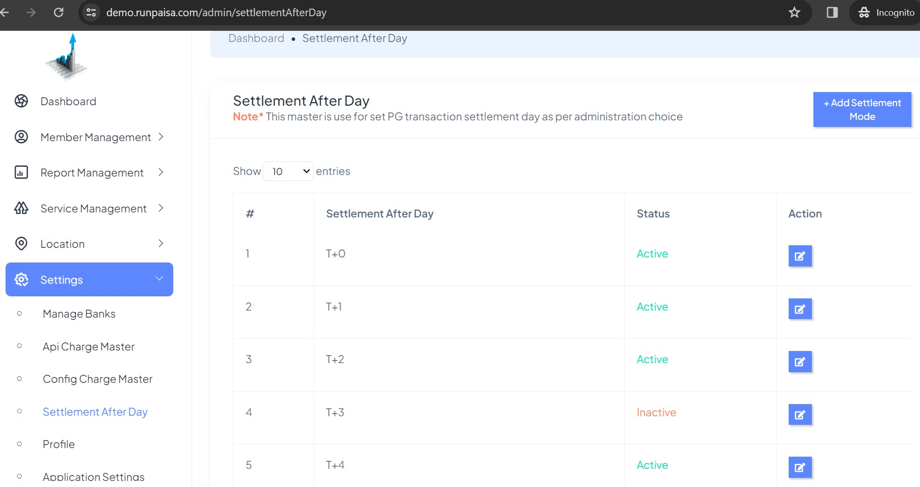
If You Inactive any of the given Settlement type, then that could not be set in PG Rates while selecting later mode.

Profile
- Profile
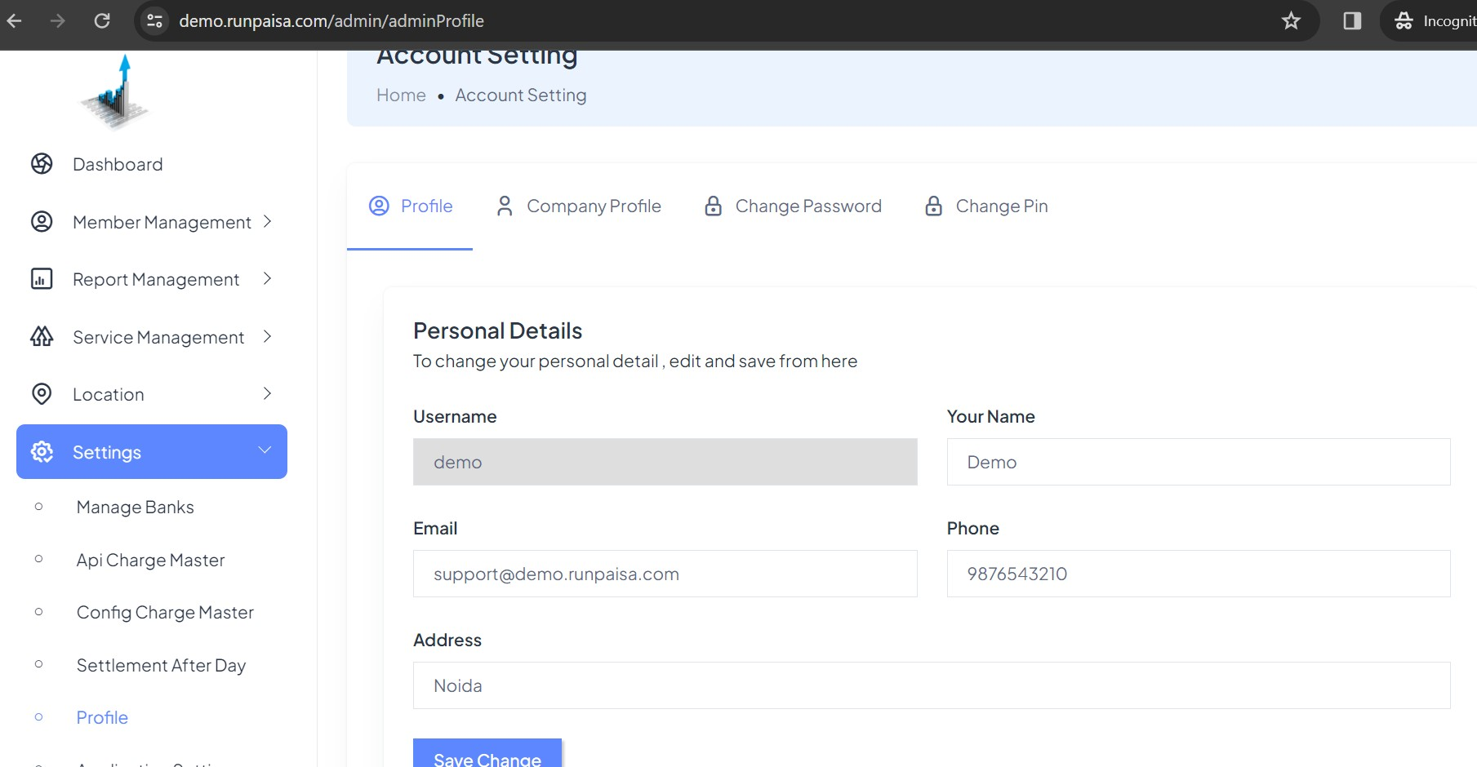In this section you can change your profile related credentials like your name, email, phone, address.

- Company Profile:-
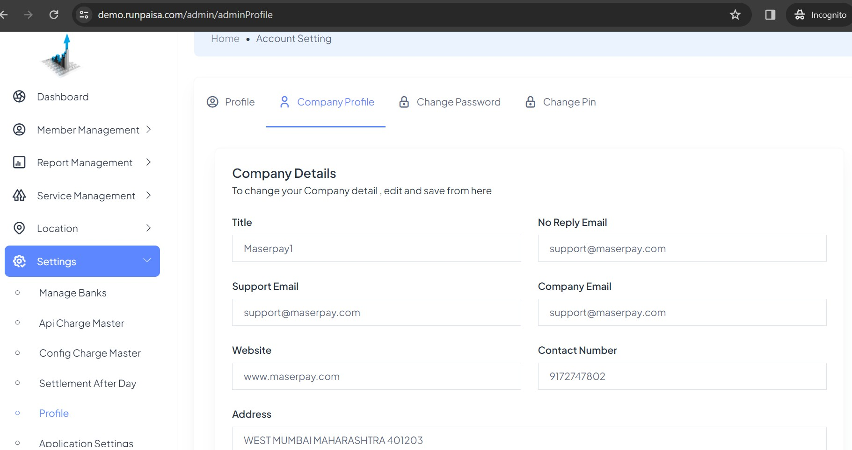In Company Profile You can see the Company details like Company title, their email id, support email id, contact number, their website url, address.

- Change Password:-
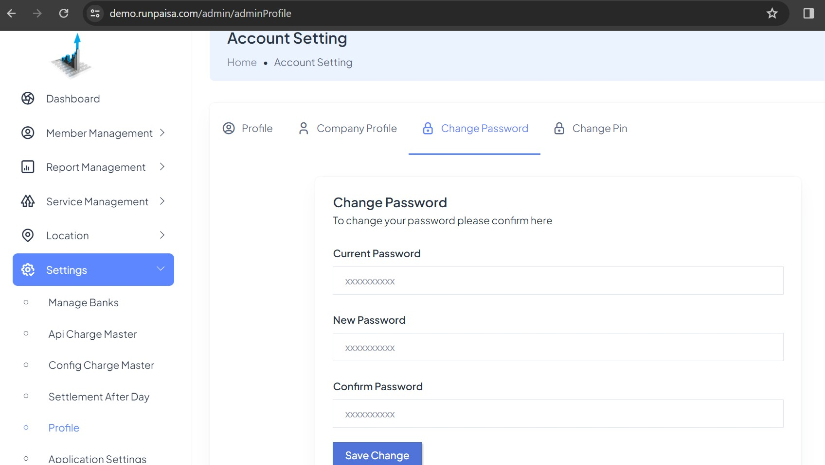This password which is used by you while login, so you may change your password here.

- Change Pin:-
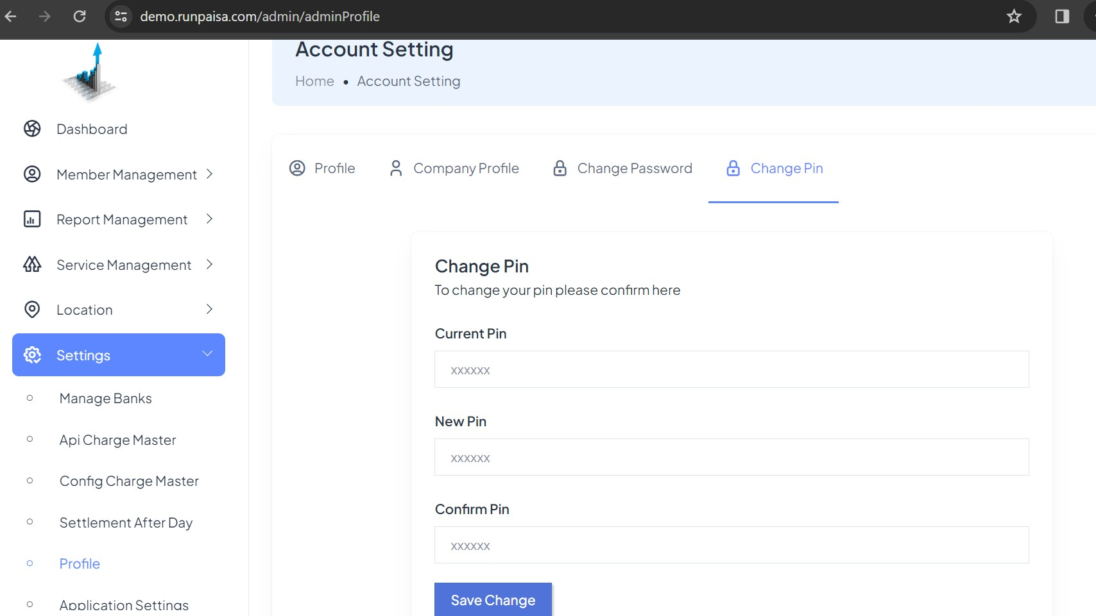This pin is used while sending money by you to your distributor and retailer. So if you want to change the pin you can change here.

Application Settings
In application setting, you can change the application and profile logo which can be seen in your profile and panel, for this you have to go to logo section in dropdown menu.

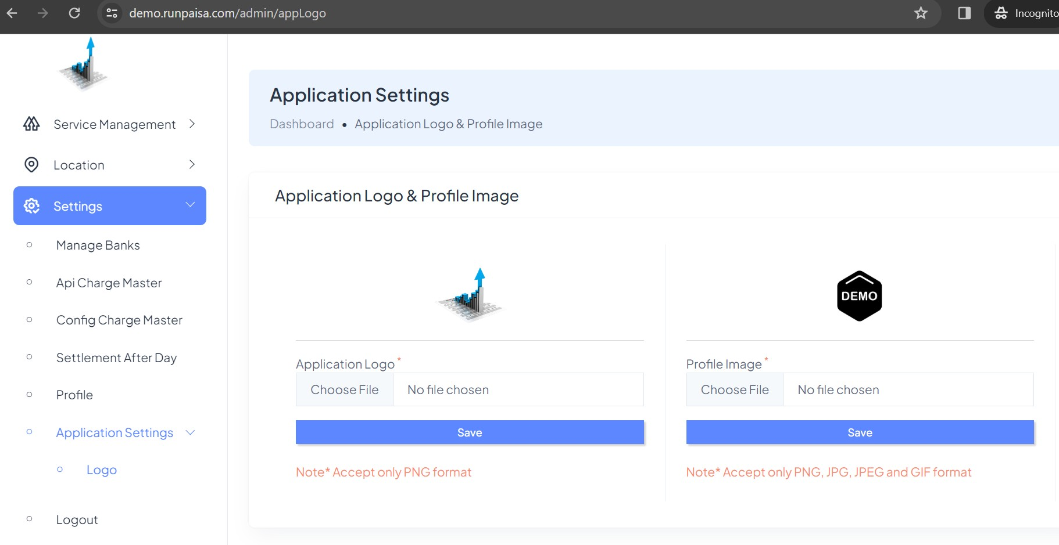Logout
When you click on logout section, you get logout.

